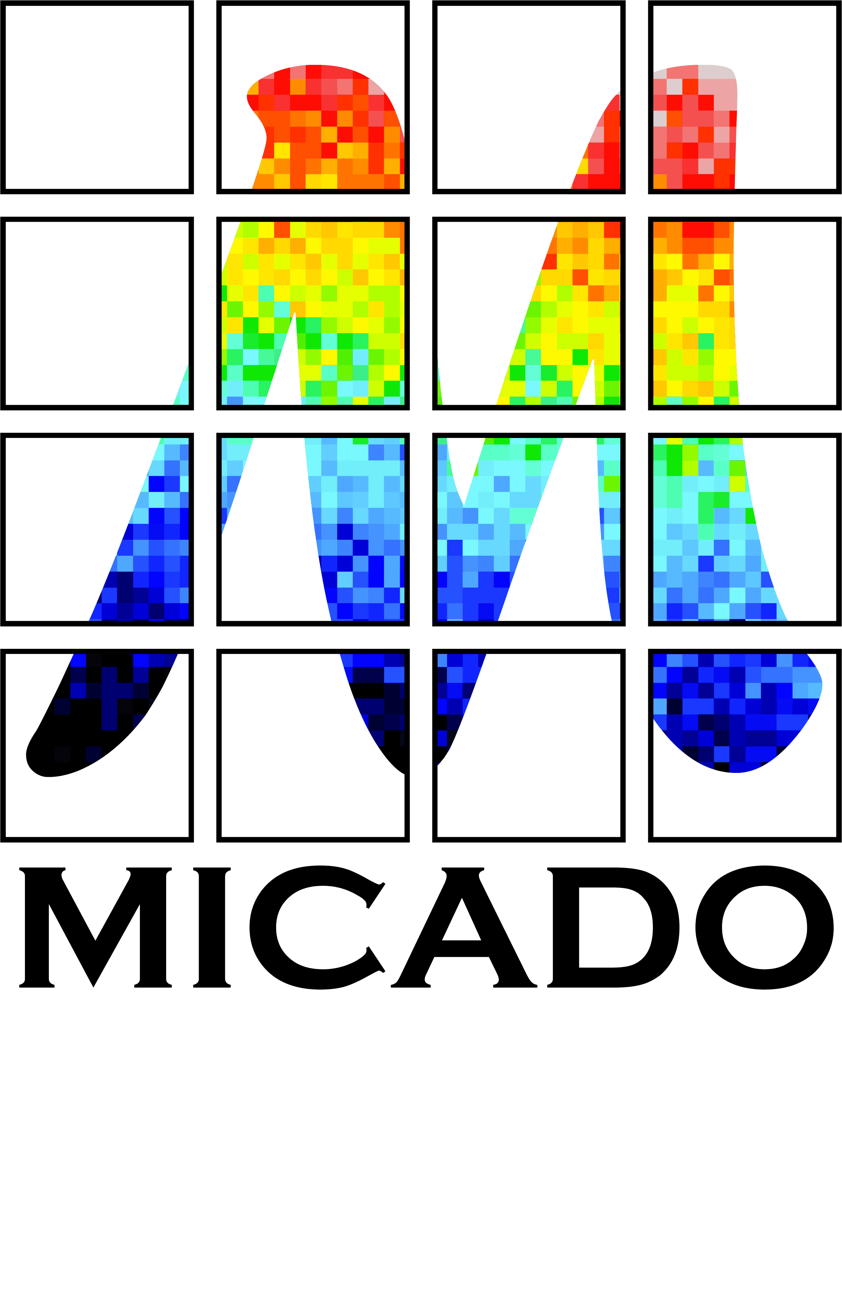


AO and MICADO:

Impact on Astrometry
  - Issue 0.5
  - Release Date 21.02.2014
  - Authors Remko Stuik, Gijs Verdoes Kleijn, Koen Kuijken, Eline Tolstoy, Tibor Agocs and John McFarland
  - Released Ramon Navarro

Executive Summary [Ramon]
The relative astrometric accuracy of MICADO is required to be better than 50 micro arcseconds relative over the FoV. This means that the contribution of the ADC must be less than 10 micro arcseconds, while the atmospheric dispersion over the observed band reaches 0.5 arcseconds (500000 micro arcseconds) and the absolute atmospheric refraction reaches 20 arcseconds (20000000 micro arcseconds). The performance of the MICADO ADC was not studied during the Phase A study.
In this study we investigate the important parameters for astrometry related to the ADC. Two different ADC designs have been investigated: an ADC in the pupil plane and an ADC close to the Image plane. In the first part of this study detailed simulations have been performed to quantify the astrometric effects including: Field dependency, wavelength dependency, Zenith Distance dependency, temperature dependency, total effect on various star types.
In order to identify cross correlation effects, also the effects of the atmosphere, Telescope, Adaptive Optics, SCAO system, MICADO, the detector and the data reduction software algorithms are taken into account in the second part of this study. The intention was to study the effects of the MAORY multi conjugate adaptive optics system, but this proved to be impossible in the time available. In effect, the single conjugate adaptive optics simulations (SCAO) were less extensive than expected (only 2 stars instead of a grid of stars) and became available only very close to the project reporting deadline. We still have questions about the simulated data and observed phenomena in this data. ADC effects still have to be added to the AO simulations of the PSF; we hope to be able to process this next week and present the results at the review meeting. Altogether this means that we cannot draw strong conclusions in this report and it might have to be treated as a progress report instead of a final report. The best conclusion is that we have 2 possible ADC designs that enable accurate astrometry: a counter rotating ADC in the SCAO pupil plane and a linear ADC just before the MICADO image mask plane. We have not found any showstoppers for accurate astrometry with MICADO and the E-ELT.

Table of Contents
Executive Summary [Ramon] 1
1 Scope and requirements [Ramon] 5
2 Science [Eline] 6
3 Impact of Adaptive Optics on astrometry [Remko] 7
3.1 Quick analysis of MAD data [Eline] 9
4 ADC Designs and trade-off [Tibor] 13
4.1 Introduction 13
4.2 Focal plane ADC-s investigated 14
4.2.1 Phase A focal plane ADC 15
4.2.2 Counter rotation based ADC (based on S-NPH2 and Spinel) 18
4.2.3 Zero deviation counter rotation based ADC (based on S-NPH2 and Spinel) 20
4.2.4 Linear ADC 21
4.2.5 Zero deviation linear ADC 23
4.2.6 Linear ADC with flat mirror 25
4.2.7 Intermediate conclusions (focal plane ADC-s) 27
4.3 Detailed investigation of the two best ADC candidates 28
4.3.1 MICADO optical model 28
4.3.2 SCAO pupil plane ADC 29
4.3.3 MICADO focal plane ADC 30
4.3.4 Tolerances 31
4.3.5 ADC optical models analyzed 32
4.3.6 Thermal considerations 35
4.4 Conclusion on ADC selection 36
5 Simulations [Remko/Gijs/John] 36
5.1 AO Simulations and Analysis [Remko] 36
5.1.1 AO simulations from LESIA 36
5.1.2 Transforming simulations into images 37
5.2 Relative astrometry on simulated images [John/Gijs] 38
5.2.1 Source extraction and centroiding 39
5.2.2 Results 42
5.2.3 Discussion 43
5.2.4 Conclusion 44
5.2.5 Next steps 44
5.3 ADC Simulations [Remko] 45
5.3.1 Simulation plots 45
7 Interfaces and requirements from the ADC [Remko/Ramon] 50
8 Conclusions [Ramon] 50
9 References [All] 51
10 Annex [Tibor] 52
10.1 Transmission of the materials used in the study 52
10.2 Material properties of materials used in the study 52
10.3 Optical aberrations (RMS vs field, RMS vs wave) 52

Scope and requirements [Ramon]

This study was triggered by the requirement to make an accurate estimate of the manpower requirements, cost and feasibility of NOVA building the Atmospheric Dispersion Corrector (ADC) for MICADO and to understand the impact of the technical trade offs on the likely scientific performance.. Here we aimed to investigate
- the requirements and feasibility of specific ADC designs
- the impact of the choices on the required accuracy of the ADC

- the
- potential assistance from software.
- to be able to make an accurate proposal to NOVA and to the MICADO consortium to build an ADC

Our performace targets are mainly driven by the exacting requirements for accurate astronomtery:
“For an unresolved, unconfused source of optimal brightness in the centre of the field of view the relative position on the sky with respect to an optimal set of reference sources must be reproducible to within 50 μas (goal: 10 μas) over all timescales in the range of 1 hour to 5 years.”

During this study it became clear that the final design of the Multi-Conjugate AO system, MAORY, is not yet decided, and thus it is currently not possible to consider it to be a driver for the design of the MICADO ADC. This study has therefore concentrated on MICADO operating with the SCAO relay. This has an impact on the science that can be done (see section 2), the field of view over which accurate astrometry is feasible (see section 3) and the locations where an ADC could be physically placed.
Furthermore, only a limited optical model was available at the time of the simulations. This means that we could only investigate the relative impact of the ADC on the optical quality, but not the impact of instrumental distortions.
Lastly, although we found a clear solution for the ADC from the point of view of optimum astrometric performance, other factors may make this rather hard to implement.

Further hard requirements are required by the second-most demanding application, which is coronagraphy. This requires a fixed orientation of the pupil with respect to the camera (i.e., the ADC should not change the relative rotation of the pupil); a pupil stability that is better than 0.5% PtV; residual chromatic errors should be <0.3 mas over a small field (Nx lambda/D) and the ADC should not cause image displacements at similar level. Note that in order to achieve the last requirement, an active feedback system might be required. Two systems were proposed (in non-coronagraphic mode readout certain stars in the field with the Hawaii 2RF, in coronagraphic mode, read out non-destructive the central area to determine residual image motions). Finally, a
ny ADC positioned up-stream from the AO wavefront sensor should have a good transmission over the wavelength range 450-720 nm.
Initially we hoped to allow for an alternate solution with two smaller ADC (one for coronagraphy, one for astrometry), however, complications both from the cooling down of such an ADC as well as from managing a moving object within MICADO removed this option from consideration at an early stage.

Science [Eline]
There are three key capabilities that exemplify the unique features of MICADO at the E-ELT and that will contribute to make it the most powerful optical/infrared instrument available until a telescope with a larger aperture is built. These capabilities lie at the heart of the primary science cases that have driven the design of the camera, and they are:
• Sensitivity and Resolution

• Precision Astrometry
• High Throughput Spectroscopy
These key capabilities will yield new insights into the structure and physics of numerous objects of astrophysical interest and allow the discovery and study of many new and/or unexplored phenomena. This superb astrometric precision means that astronomical sources need no longer be static but become dynamic. Historical examples demonstrate that attaining dramatic new additional capabilities leads to breakthroughs. In this case we expect to expand our understanding of the three dimensional structure and evolution of a range of targets. Spectroscopy over a long wavelength range has also been shown to be a very powerful diagnostic (e.g., X-shooter on the VLT), especially for the discovery and characterization of new sources over a range of red-shift and also to cover different types of sources (from stars, Supernovae explosions and GRBs to galaxies).
A fundamental requirement for all these capabilities is a well understood and well behaved point spread function. The planned adaptive optics modules make the fundamental corrections required for the atmospheric conditions, but an ADC is also required to correct for the wavelength dependent refractive index of air. The ADC will be needed for all broad-band observations which require optimum sensitivity and spatial resolution. The capability most affected by the functioning of the AO and the ADC is the precision astrometry.
It now seems likely that MICADO will operate for the first years using its own internal SCAO module. This was an executive decision by ESO. Thus the SCAO module is currently the only AO option which is sufficiently well defined for us to be able to design an ADC. The SCAO mode makes astrometry (and photometry) somewhat more challenging than the MCAO module, but it is also easier to predict how it will work and interact with the ADC, as this is a more standard and simple form of AO correction. It is also very convenient that the SCAO module is part of the MICADO instrument and the group building it is part of the MICADO team.
The SCAO mode produces a higher strehl ratio than the MCAO system, and so it has always been the ideal tool for studies of the central regions of (active) galaxies, including but not restricted to the Galactic centre. Also the gravitational lensing science case may prefer to use SCAO, as it is typically concerned with very small spatial scales, and does not require a large field of view. The only science cases which will most likely have to wait for an MCAO system is the wide-field astrometry cases looking at nearby galaxies and globular clusters and deep imaging of blank sky fields looking for high redshift objects. However, even with SCAO the small and compact central regions of globular clusters can still be accurately monitored for astrometric studies. Likewise the detailed imaging of individual (known) high redshift galaxies may prefer SCAO because they don't need a large field of view and they would also benefit from the increased strehl.

Thus the change of strategy coming from ESO, to delay the MCAO module, does not significantly affect the Dutch scientific plans for MICADO. In fact it makes it easier to develop the scientific program in stages, starting with the simpler small-field approach before going to the large fields of view.

Impact of Adaptive Optics on astrometry [Remko]
Based on earlier discussions and write-ups by Trippe, Ellerbroek and others, we can identify properties of Adaptive Optics that impact the astrometry:
- The overall tip-tilt stability is dominated by the ground layer and vibrations of the telescope. There are two effects; the PSF is blurred by the given TT-stability and the actual position of stars is perturbed. The latter is less important for relative astrometry, as all stars in the field undergo the same tip-tilt motion. The blurring of the star means that the PSF of the star is effectively convoluted with a blur with a FWHM of several mas. The exact shape of this blur depends heavily on the time scales of the TT-jitter and the exposure time. For METIS, the overall RMS tip-tilt fluctuations, based only on stochastical AO simulations, are estimated to be of the order of 5 mas.
- The long term stability of tt-signal does not deviate significantly from this number. The stability is given by the stability of the loop and as long as the loop remains closed, TT-residuals might scale with external factors, but variations will be small. Outside this range, the observing conditions have deteriorated so much that in practice the observation will be stopped. Considering this, and that these residuals are random, a SQRT(t) decrease in position and a fixed value of <5 mas in blurring can be assumed, also on longer time scales.
- MCAO relies on several stars (~3) in the field for lower order mode correction. Individual stars have a stability as described above, but for relative astrometry, it is the relative stability of these stars as a function of time. This requires a separation between correlated motions and uncorrelated motions. The first relate directly to motions induces by the ground layer turbulence plus vibrations, while the latter relate to higher-layer turbulence. In strength, the separation is of the order of ~90% common motion and ~10% non-common motions. Using the number above, the relative motions of the guide stars will leave uncorrected scale variation of the order of 500 microarcseconds over the 1 arcmin field of view. This scale factor will average out as a function of time, with SQRT(t), but will leave a position dependent blurring of the PSF, varying between 0 at the weighted center of the guide stars, and up to 250-500 micro-arcseconds at the edge of the field of view. The blurring is non-symmetric, but aimed at the center of the weighted center of the guide stars.
- Stability of the Laser Guide Star Tomography – probably can be included into PSF stability.
- PSF centroiding stability falls into two categories; the accuracy with which the centroid of a specific PSF can be determined and the impact of the halo of the surrounding PSFs on the centroiding accuracy. The centroid of the PSF depends on the instantaneous distribution of the turbulence in the atmosphere, as compared to the correcting elements, i.e. the 3 DMs in the system. If the atmospheric profile would be stable, the temporal fluctuations on the PSF shapes will average out as SQRT(t) and is only dependent on the position. With a varying atmospheric profile, the PSF will only stabilize as SQRT(N), where N is the number of independent configurations of the atmosphere. In practice there will only be a few realizations of N during an exposure, which means that the PSF will not stabilize. The only way to solve this is by very careful calibration of the PSF, or might be determined by PSF reconstruction based on WFS data. The latter might not include all cross-coupling effects, like ADC and drifts in the NCPA’s.
- Scintillation – In the classical regime, scintillation is mainly an intensity fluctuation, but using MCAO, scintillation might also introduce local plate scale variations. These variations are directly coupled to the instantaneous wavefront disturbances and should therefore, for exposures significantly longer than the crossing time of turbulence (~1-2 seconds) decrease with SQRT(t). The initial magnitude of the effect needs to be investigated, but expected to be small with respect to, for example, the plate scale variations due to the positioning inaccuracies of the natural guide stars. For now these are neglected.
- Orientation of the field between exposures will cause that some of these effects, that are in principle reproducible, will have different impacts for each observation. Keeping the orientation the same, i.e. observing at the same sidereal time, would allow for a reduction of some of the error terms.
- Higher order terms due to vibrations?
- Chromatic variations in the PSF. The AO correction is chromatic, in the sense that the atmospheric wavefront are chromatic, while the corrections are not. The residuals are therefore chromatic and cause a wavelength dependent PSF. This chromatic variation can change as a function of space and time.
- Mixing terms with other (astrometric) effects?
  - The guide stars will be at different Altitudes, each having a different atmospheric refraction. Since the guide stars are part of the same reference grid as the stars for which you want to know the position, this linear term of this effect is already taken into account. But since the AO system performs a linear interpolation between its guide stars, any higher order terms in the atmospheric refraction are not accounted for. LEVEL: ????
  - More?

From the above, it should be concluded that the main issues are in the determination of the center of the PSF under varying atmospheric conditions and in varying positions in the field. Some of the detrimental effects of not being able to do a full simulation can be mitigated by careful studying of the PSF calibration.
Furthermore, several of the above effects also come into play for SCAO systems, for which we do have the tools to run simulations. Considering the complexities of the MCAO system, it is also conceivable that MICADO will run several years with only the SCAO system operational. Running SCAO simulations now has the added benefit that it will allow for assessing the availability of high-precision astrometry in the first few years of MICADO.
The differences in correction between SCAO and MCAO impacts astrometry in two areas; 1) the Point Spread Function (PSF) will vary significant over the field of view. This will severely impact the centroiding and 2) the correction is only performed in a single direction, which can cause unsensed plate scale variations, local and global, over the field of view, which can be expected to be stronger at larger distances from the guide star.

Quick analysis of MAD data [Eline]
Koen Kuijken ran a quick analysis of existing MAD data from the VLT. These data consisted of a series of 20 exposures, 10 seconds each, in K band, over a time span of 1.5hrs (2008-08-16T01:18:22 to 2008-08-16T02:40:48). The images contain the outer regions of globular cluster NGC 6441, a dense star field. Each MAD image is ~50 arcsec square, and 2048x2048 pixels with a scale of 28 mas/pix. See Figure 1. The dithers between exposures extend over more than 200 pixels. Stars in the images have a Gaussian FWHM of about 5 pixels. These images were not taken with the aim of carrying out astrometry.
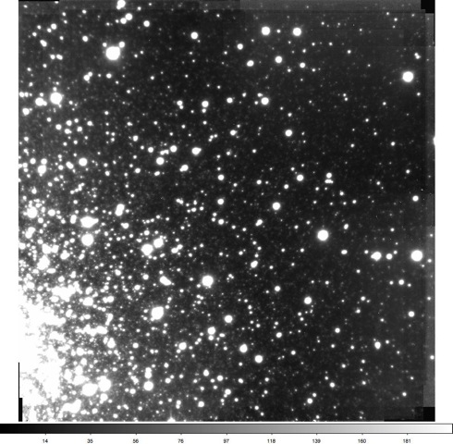
Figure 1. Test image of the outer region of globular cluster NGC6441, which was used to estimate astrometric accuracy of the MCAO imager, MAD on the VLT.
The analysis carried out was similar to what was done previously with HST images (eg Kuijken & Rich 2002 AJ 124, 2054). It works by determining the pixel position of all the stars in each exposure by PSF fitting (in this case a 'shapelet'=gaussian*polynomial model is used), and then to astrometrically map the fields to a common reference system using polynomial distortion maps. This process is iterated with 3-sigma clipping to remove outliers. For this analysis only the ~250 brightest stars in the image were used, and excluding the crowded corner near the center of the star cluster. All stars measured stars were given equal weight.
Figure 2 shows the results of this analysis, for distortion models of increasing complexity (from linear = 3 coefficients to 4th order polynomial = 15 coefficients). Note that each exposure gets its own distortion model, and no assumption about temporal stability is made: only the stars in the field are used as the calibrators. Each panel shows the rms position dispersion after 3-sigma clipping: every point is a different individual star, and the plotted dispersion is the RMS of the 20 remapped positions. The curve is the same in each plots, and shows the 1/sqrt(flux) dependence that would be expected from pure photon noise.

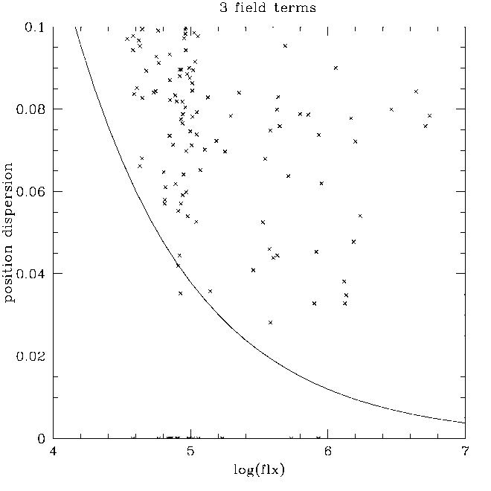 | 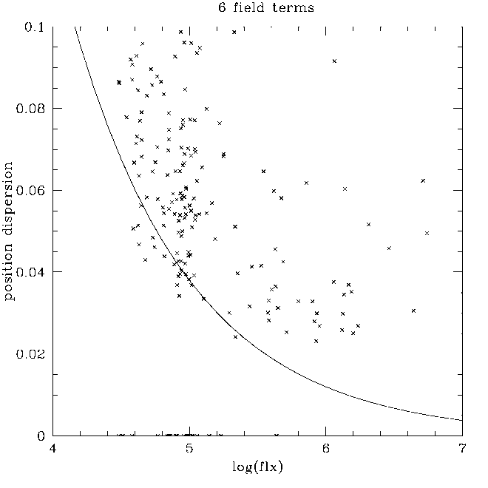
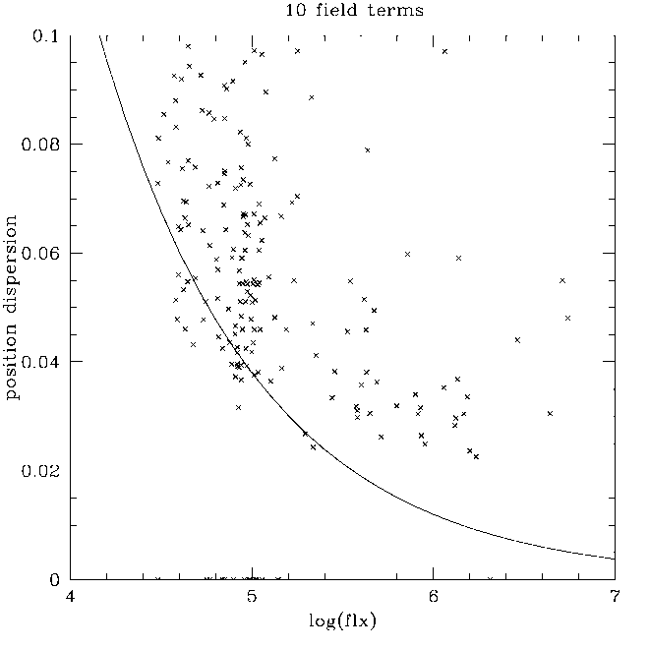 | 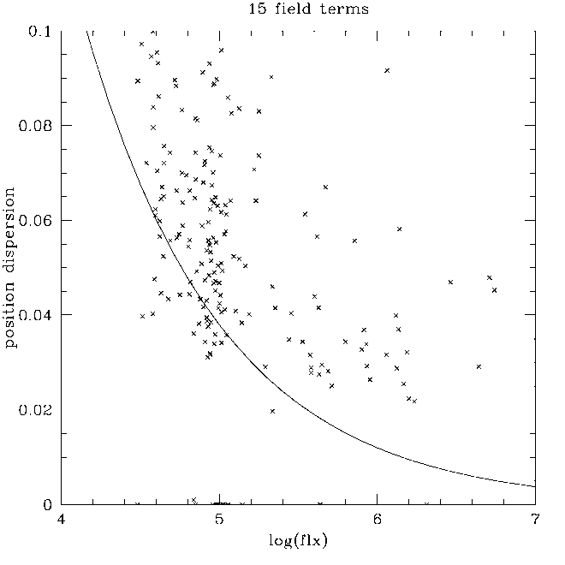
Figure 2. Results of the astrometric analysis of a sequence of VLT/MAD images, like those shown in Figure 1, for increasing order of a polynomial fit of a distortion model.
It is clear that there is little difference between the cubic and quartic distortion models. A 'floor' of about 0.03pix rms is evident. Even the rms of the brighter stars does not fall below this level. The reasons for this floor could be manifold: e.g. pixel sampling effects (although unlikely for these very well resolved stars), atmospheric dispersion (MAD had no ADC), or high-order field distortion terms induced by the AO. All this would need to be investigated by correlating the residuals against pixel phase, color, distance from the guide stars, etc. But this relatively straightforward analysis already shows that it is possible to achieve an rms position of .03 pixel with these data, which is 850 micro-arcseconds, with a single 10-sec exposure with an MCAO system on the VLT. How this will average down can only be demonstrated with multi-epoch observations, but with properly dithered data it will: so 850 micro-arcseconds is likely to be a very conservative upper limit of what can finally be achieved. The residual error maps are shown in Figure 3.
Simple scaling of these results to the pixel scale of MICADO, i.e. 3 mas leads to an rms astrometric precision of ~100microarcsec accuracy.

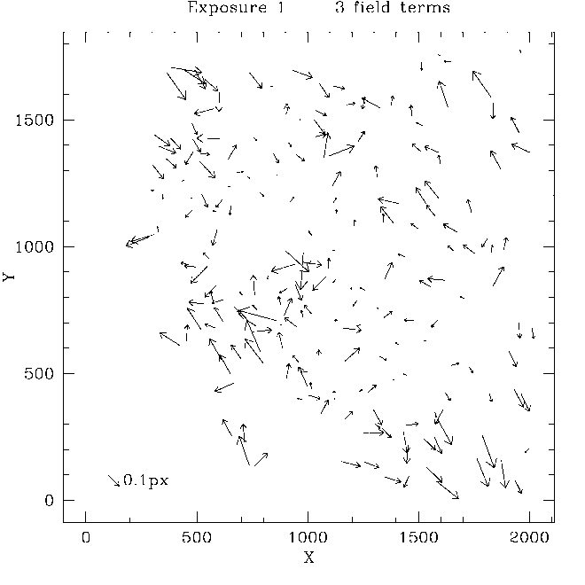 | 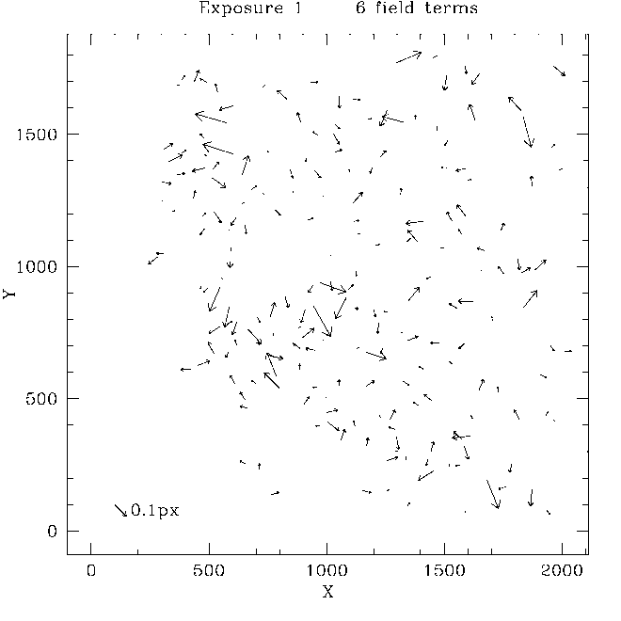
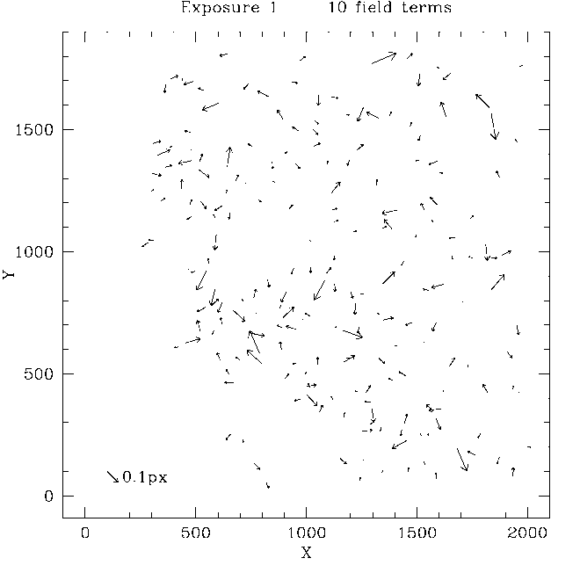 | 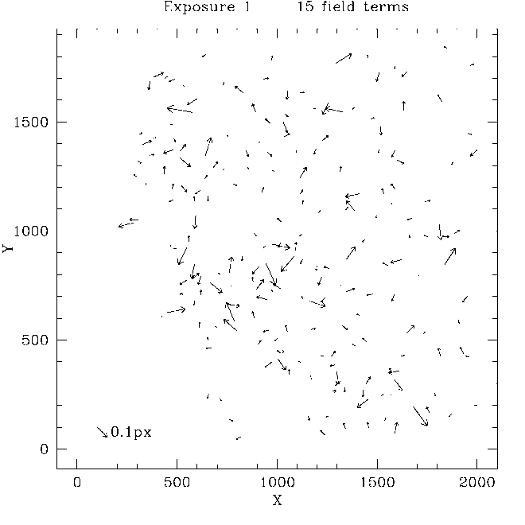
Figure 3. Three example residual error maps for the various polynomial distortion models from the results shown in Figure 2. No immediate correlation can be seen with a 3-guide-star configuration, but further work needs to be done on this.

ADC Designs and trade-off [Tibor]

Introduction
The aim of this study is to investigate the different ADC configurations for the (SCAO-)MICADO system and bring the analysis to a level where the performance, tolerances and cost of the ADC can be evaluated against several aspects of the science operation of MICADO.
In the previous phase of the project a short study was done, in which we compared two types of counter-rotating ADC-s:
- The ADC as described in the MICADO Phase A Opto-Mechanical design. This is a set of counter-rotating prisms made up of ZnSe/ZnS. This ADC is located ~450 mm before the focus (of the telescope). In order to correct the optical errors caused by locating the ADC close to the image plane, two of the surfaces of the ADC have a small cylindrical curvature (~500 meter).
- A similar set of ZnSe/ZnS counter rotating prisms located in a pupil plane of the MCAO system before MICADO, with the angles optimized for performance over 0.58 -2.50 micrometers.
The result of the study showed that the counter-rotating pupil plane ADC was performing much better than the focal plane ADC.
In the continuation of the previous phase several additional ADC-s were investigated both in the focal plane of MICADO and pupil plane of the SCAO/MCAO systems. We identified and investigated two ADC types:
- Counter rotation based designs (already mentioned before). Two counter rotating prism pairs introduce the necessary dispersion. This type of ADC-s can be placed in the pupil plane or in the focal plane of the optical system.
- Linear ADC. Two prisms with varying separation between them produce the necessary dispersion. This type of ADC works only in the vicinity of the focal plane.
For both of these designs we look at zero-deviation versions, which means that we intend to find solutions, where the optical axis displacement or tilt is minimized.
In section 4.2, focal plane ADC-s are investigated and trade-off between them is presented. Section 4.3 describes the two best ADC designs: a linear ADC in the focal plane of MICADO (selected from the designs showed in section 4.2) and a counter rotation based ADC in the pupil plane of the SCAO system. Many other designs were investigated, but not shown in the following. They were eliminated on the basis of the following criteria:
- unacceptable chromatic spread of the PSF (residual dispersion)
- the insufficient pupil performance inside MICADO
- problematic ADC materials (transmission, manufacturability)

Focal plane ADC-s investigated
In the following sub-section, six focal plane ADC-s are analyzed:
- The original focal plane ADC that is detailed in the MICADO phase A document.
- A counter rotation based ADC with a very good material combination (S-NPH2 and Spinel) to match the atmospheric dispersion in the 0.8-2.5 micron range.
- Same as in point 2, but with zero deviation (meaning that there is no spot drift in the focal plane as the ADC rotates).
- Linear ADC.
- Same as in point 4, but with zero deviation (no spot drift in the focal plane as the linear ADC moves).
- Linear ADC with fold mirror.
A 0.014°x 0.014° square field of view and 0.8-2.5 µm wavelength range was modelled for the analysis and optimization of the ADC-s. For all designs six figures are presented. In the first two figures the spot diagrams are shown (MICADO detector plane) for 0 degree and 65 degrees zenith angle. In the third figure the residual dispersion, in the forth the spot drift in the focal plane (or pupil tilt) are presented. Finally in the fifth and sixth figures the pupil shear are shown, first for one wavelength for different zenith angles (represented by different colors) and secondly for 65 zenith angle for different wavelength (represented by colors). In the Annex the RMS spot radius vs field and RMS spot radius vs wavelength are also included for the worst case 65 degree zenith angle configurations.
For the sake of comparison, in all designs the first optical surface is 565 mm before the focal plane (this was the location of the original phase A ADC). The most recent space envelope for the focal plane ADC is a 250mm wide volume 200mm before the focal plane. All the designs presented in the following can be accommodated for this space envelope, although for the linear ADC generally more space is needed and in some cases it can lead to difficulties (zero-deviation versions need more space).
For all designs telecentric and non-telecentric relays were both considered and analyzed. In most of the cases the results were the same. Situations, where the results were different are detailed in the specific sections.

Phase A focal plane ADC
In the following we look at the performance of the system using the original phase A design of the ADC. The materials are ZnSe and ZnS and the first and last optical surfaces are cylindrical.
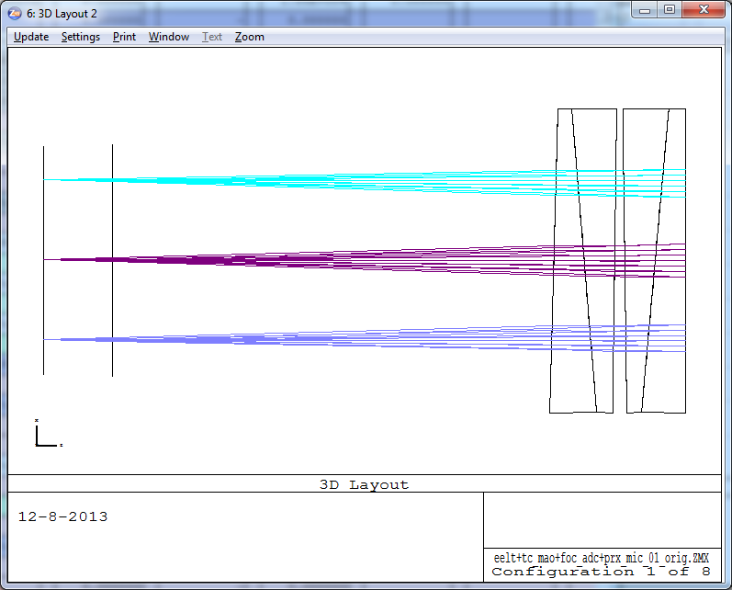
Figure 4 Layout of the phase A ADC. The focal plane with and without the ADC is also shown.
In the following the spot diagrams can be seen for 0 degree and 65 degrees zenith angle.
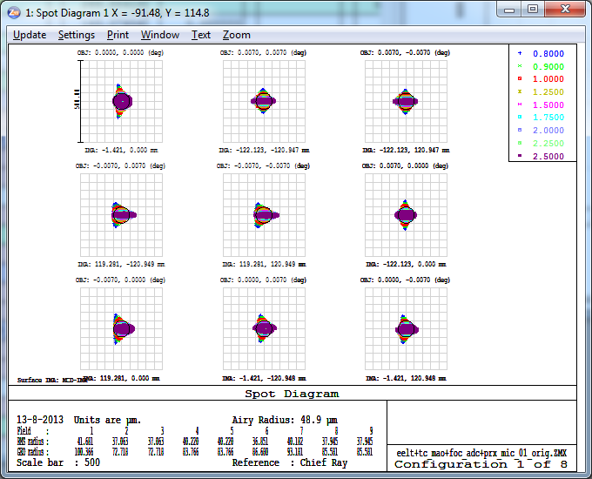  Figure 5 Spot diagrams for zenith (in the MICADO detector plane). Scale is 500 microns. | 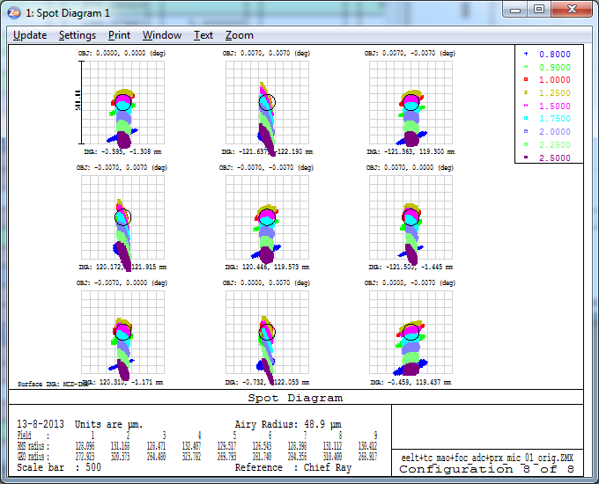  Figure 6 Spot diagrams for zenith angle 65 degrees. Scale is 500 microns.
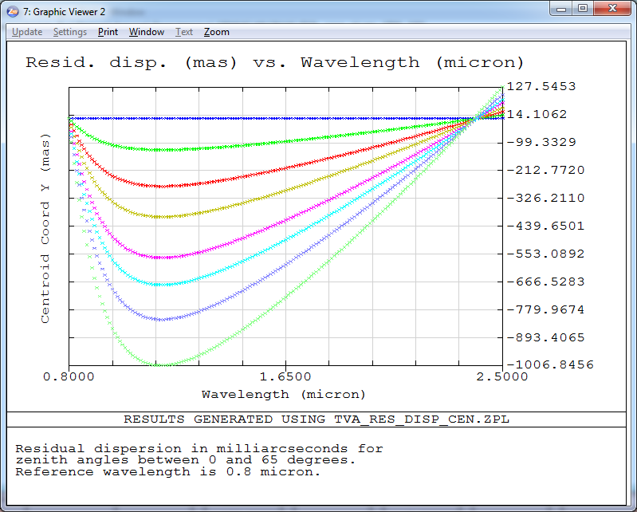  Figure 7 Residual dispersion in mas (PV is 1135 mas) for zenith angles 0, 15, 30, 40, 50, 55, 60 and 65 degrees. | 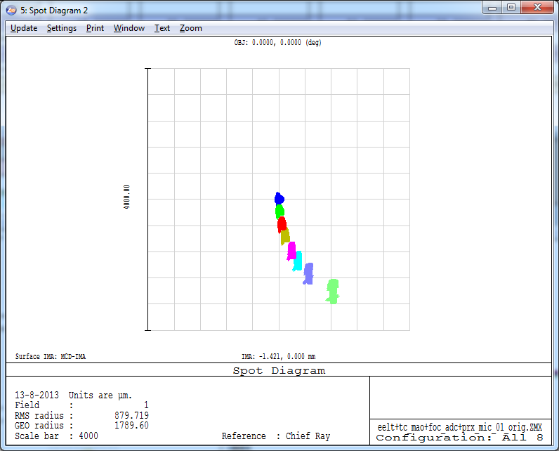  Figure 8 Spot drift is around 4mm as the ADC rotates. Spots for zenith angles 0, 15, 30, 40, 50, 55, 60 and 65 degrees are shown.
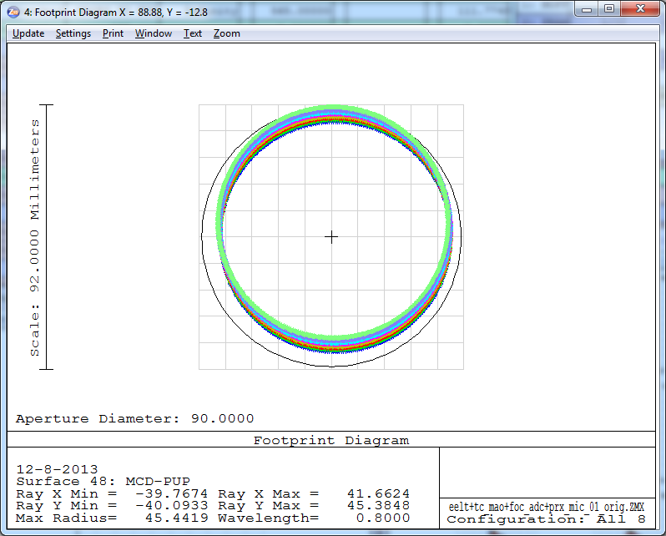  Figure 9 Pupil shear for 0.8 micron wavelength. The colours represent different zenith angles. | 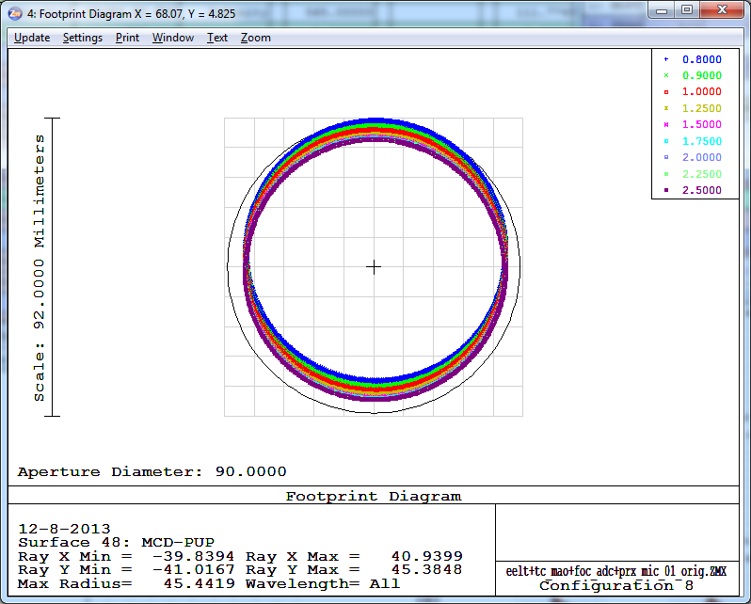  Figure 10 Pupil shear for 65 degrees zenith angle. The colors represent wavelengths between 0.8-2.5 micron.
The non-telecentric relay has two effects on the phase A ADC. The residual dispersion and the chromatic pupil shift decreases. This is understandable since the phase A ADC was designed for a non-telecentric MAORY. The residual dispersion and the pupil shift for one wavelength can be seen in the following figures.
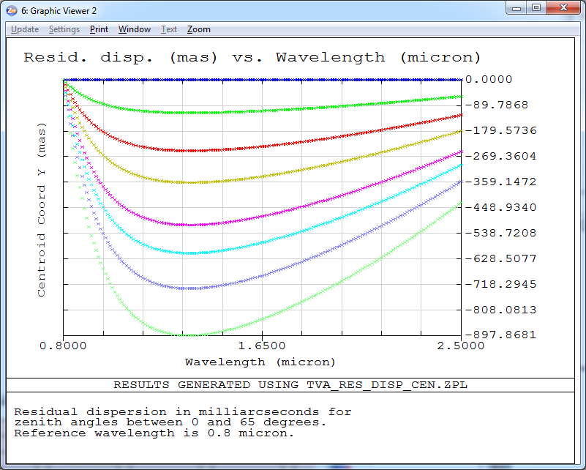  Figure 11 Residual dispersion in mas (PV is 898 mas) for the zenith angles 0, 15, 30, 40, 50, 55, 60 and 65 degrees. | 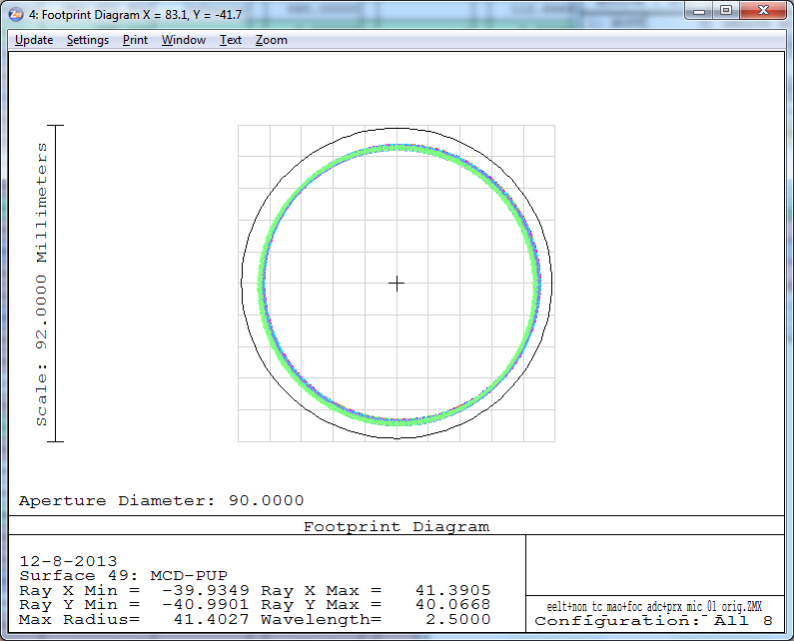  Figure 12 Pupil shear for 0.8 micron wavelength. The pupil quality is similarly good for all wavelength. (The colors represent different zenith angles.)

Counter rotation based ADC (based on S-NPH2 and Spinel)
In the following a counter rotation based ADC is investigated, which consists of materials S-NPH2 and SPINEL. This material combination was found in literature [1] as the best that compensates atmospheric dispersion in a very similar wavelength range required. Similarly to the previous section, the spot radii, residual dispersion, pupil shear and spot drift in the focal plane (pupil tilt) are shown. This ADC is very similar to the phase A ADC, but it only contains flat surfaces.
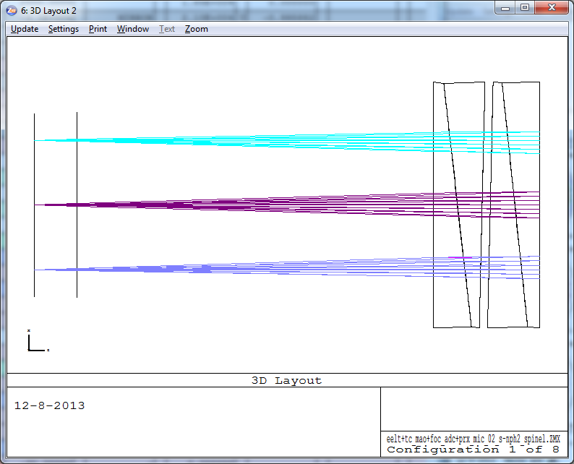
Figure 13 Layout of the counter rotation based ADC. The focal plane with and without the ADC is also shown.
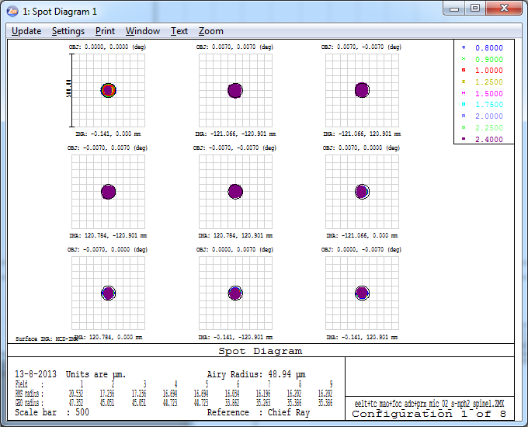  Figure 14 Spot diagrams for zenith in the MICADO detector plane. Scale is 500 microns. | 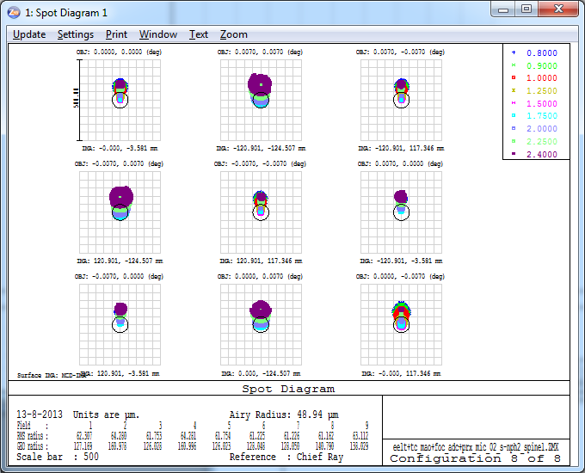  Figure 15 Spot diagrams for zenith angle 65 degrees. Scale is 500 microns.
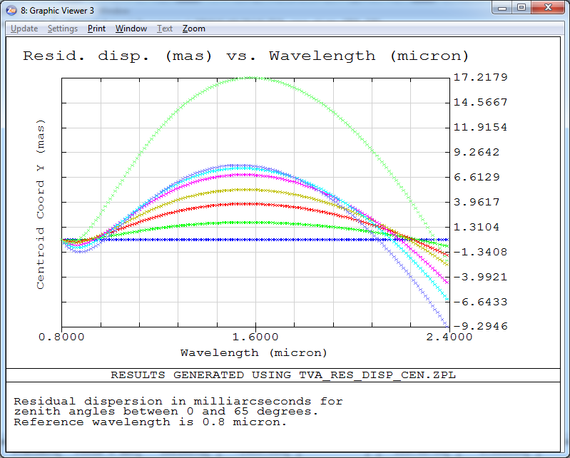  Figure 16 Residual dispersion in mas (PV is 27 mas) for the zenith angles 0, 15, 30, 40, 50, 55, 60 and 65 degrees. | 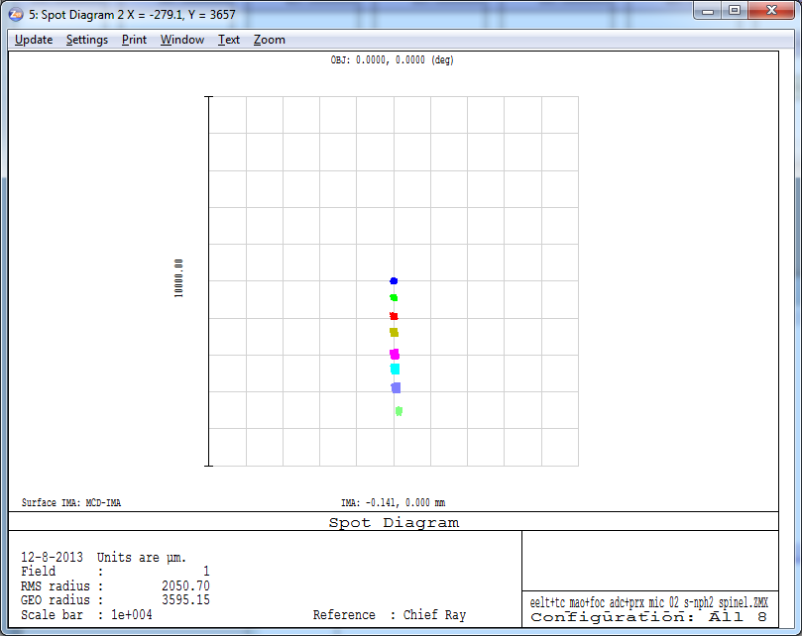  Figure 17 Spot drift is around 7mm as the ADC rotates. Spots for zenith angles 0, 15, 30, 40, 50, 55, 60 and 65 degrees are shown.
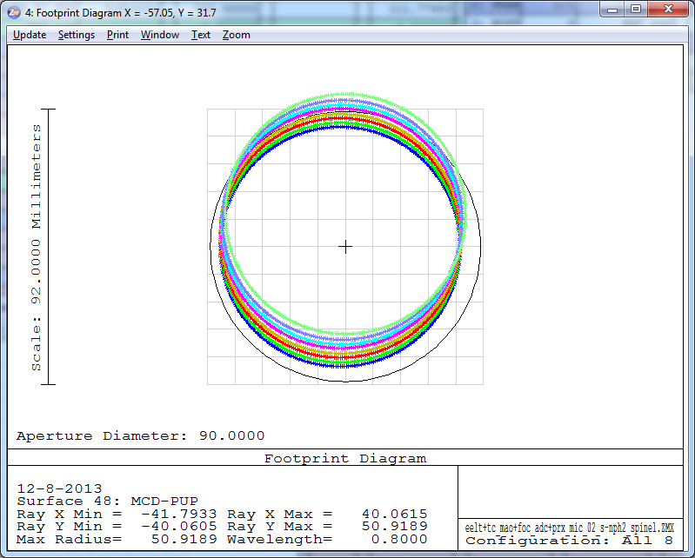  Figure 18 Pupil shear for 0.8 micron wavelength. The colours represent different zenith angles. | 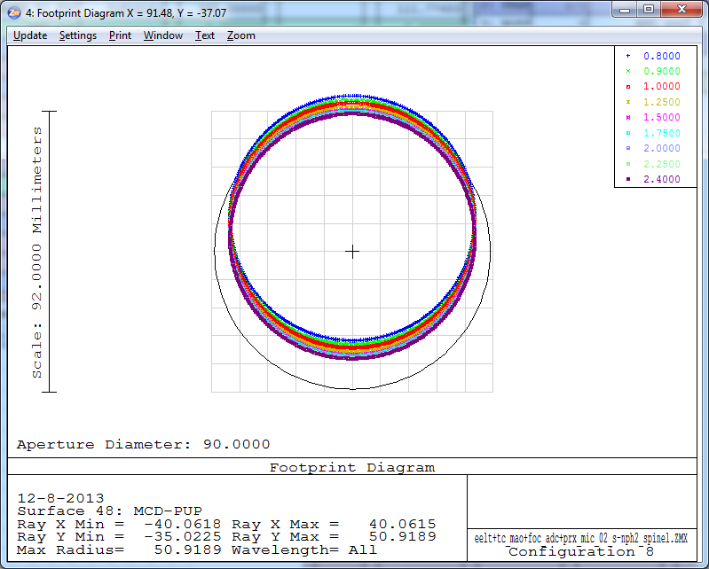  Figure 19 Pupil shear for 65 degrees zenith angle. The colors represent wavelengths between 0.8-2.4 micron.

Zero deviation counter rotation based ADC (based on S-NPH2 and Spinel)
In the following the ADC configuration from section 2.2. was re-optimized in order to reduce the spot drift (the result can be seen in Figure 21). The spot diagrams are almost identical to the previous design so they are not shown below.
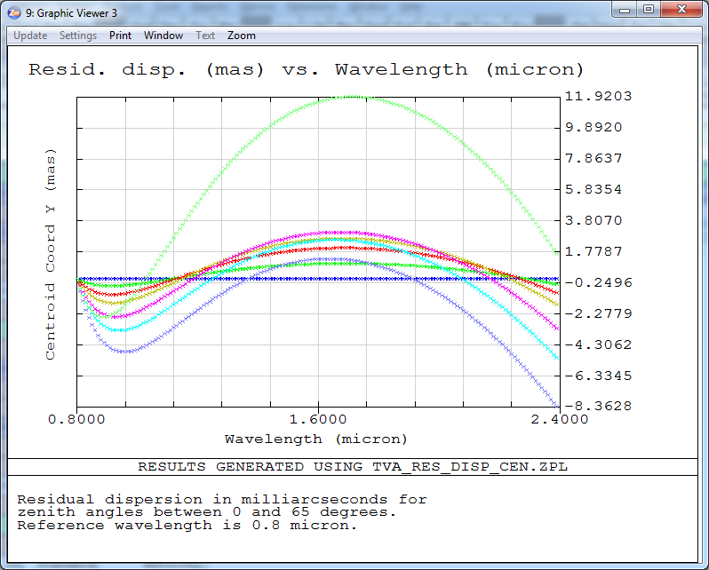  Figure 20 Residual dispersion in mas (PV is 20 mas) for the zenith angles 0, 15, 30, 40, 50, 55, 60 and 65 degrees. | 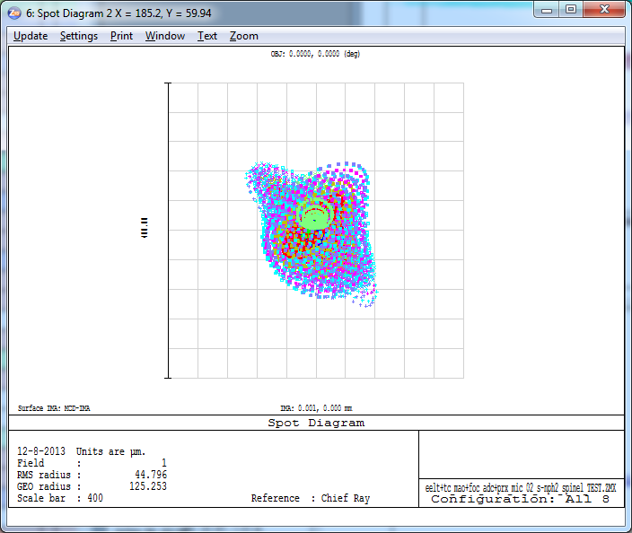  Figure 21 Spot drift is reduced to essentially 0 as the ADC rotates.
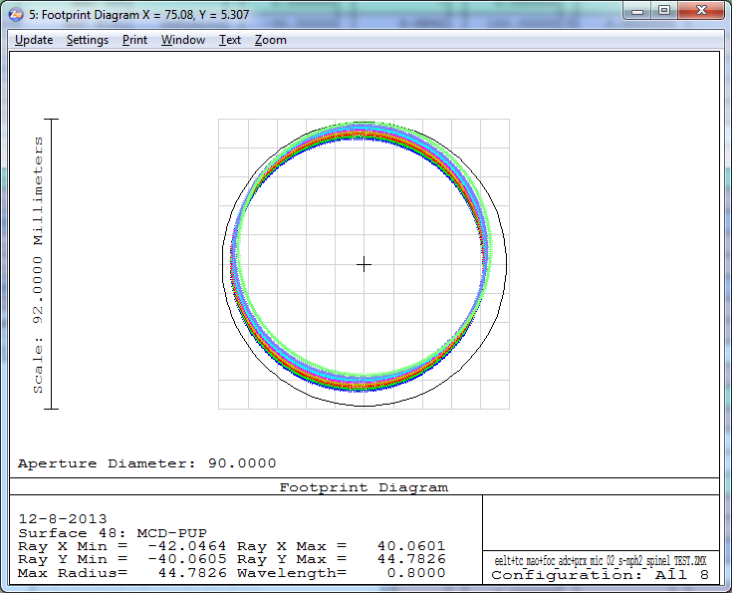  Figure 22 Pupil shear for different wavelength is also reduced (here the 0.8 micron pupils can be seen). The colors represent different zenith angles. | 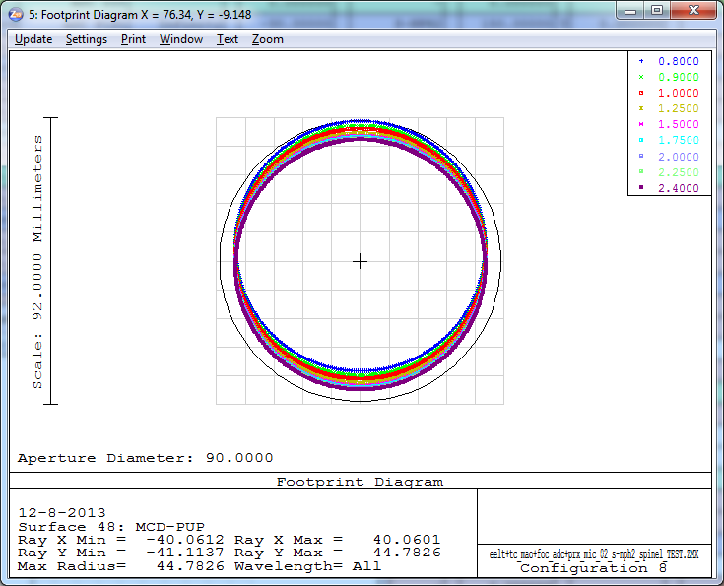  Figure 23 Pupil shear for 65 degrees zenith angle. The colors represent wavelengths between 0.8-2.4 micron.

Linear ADC
In the following the linear ADC (with two ZnSe prisms) is investigated. The layouts for 0 and 65 degree zenith angle scenario are shown below. The travel of the second component is 300mm in this particular case, but it can be reduced to 150mm if need without introducing significant optical aberrations (the prism top angle increase as the maximum travel shortens between the components). As one of the ZnSe prisms is moving, the optical axis is displaced and also some defocus is introduced. The optical axis decentre is 40mm directly after the ADC, which means 60mm spot drift in the MICADO detector plane. The defocus needed is 2.5mm for the 0-65 degree zenith angle range directly after the ADC.
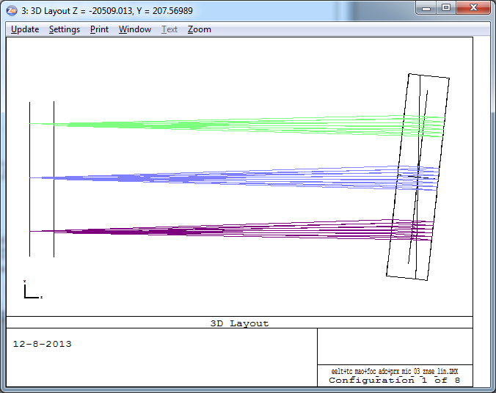  Figure 24 Layout of the linear ADC for zenith angle 0 deg. | 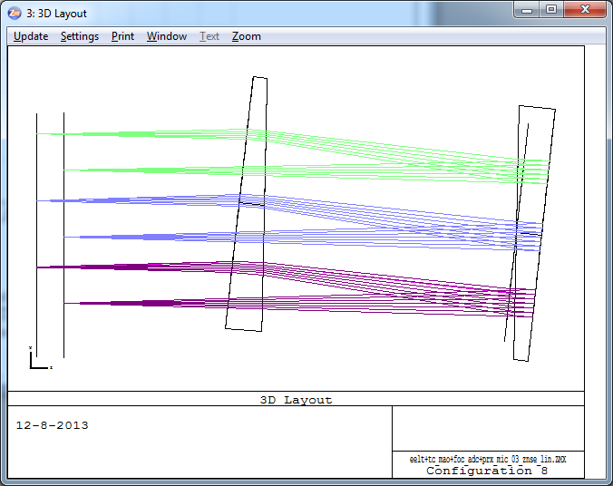  Figure 25 Layout of the linear ADC for zenith angle 65 deg.

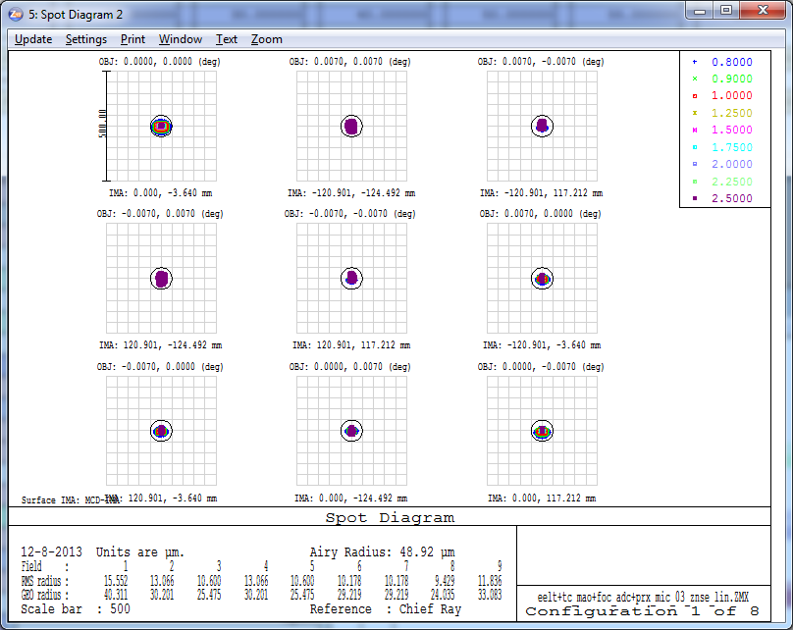  Figure 26 Spot diagrams for zenith angle 0 deg in the MICADO detector plane. Scale is 500 microns. | 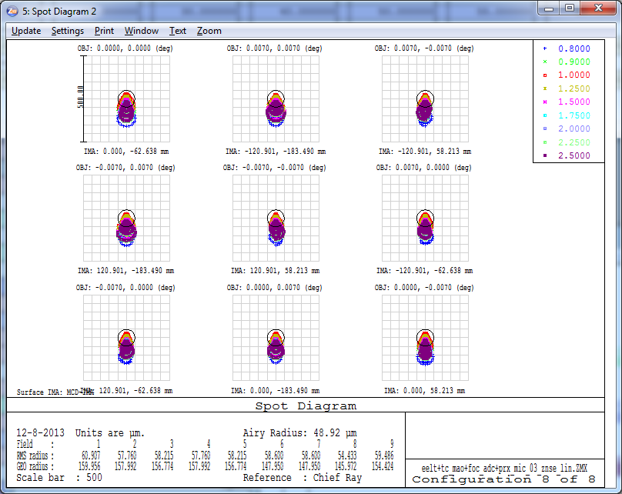  Figure 27 Spot diagrams for zenith angle 65 deg. Scale is 500 microns.
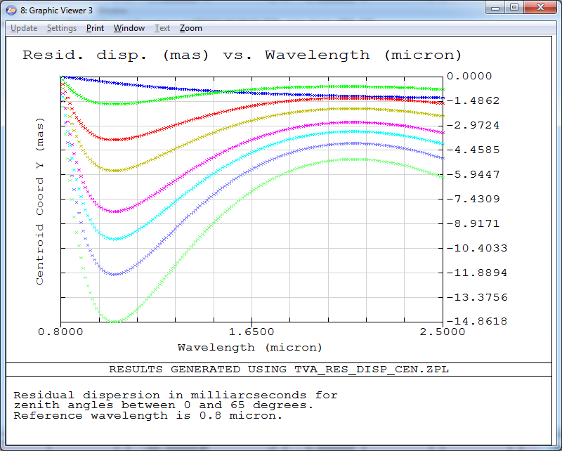  Figure 28 Residual dispersion in mas (PV is 15 mas) for the zenith angles 0, 15, 30, 40, 50, 55, 60 and 65 degrees. | 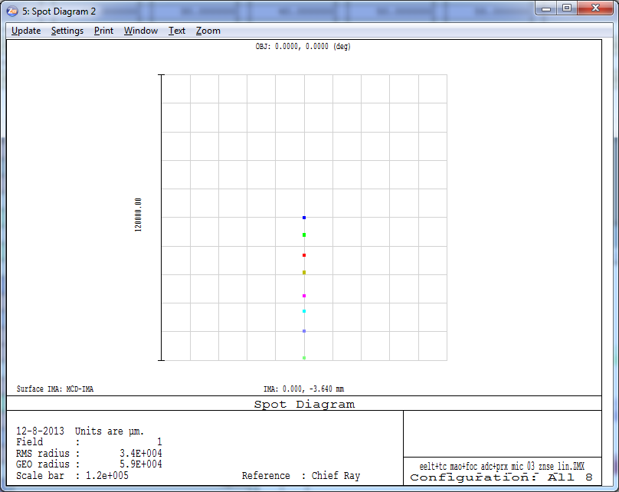  Figure 29 Spot drift is around 60mm (!) as the ADC rotates. Spots for zenith angles 0, 15, 30, 40, 50, 55, 60 and 65 degrees are shown.
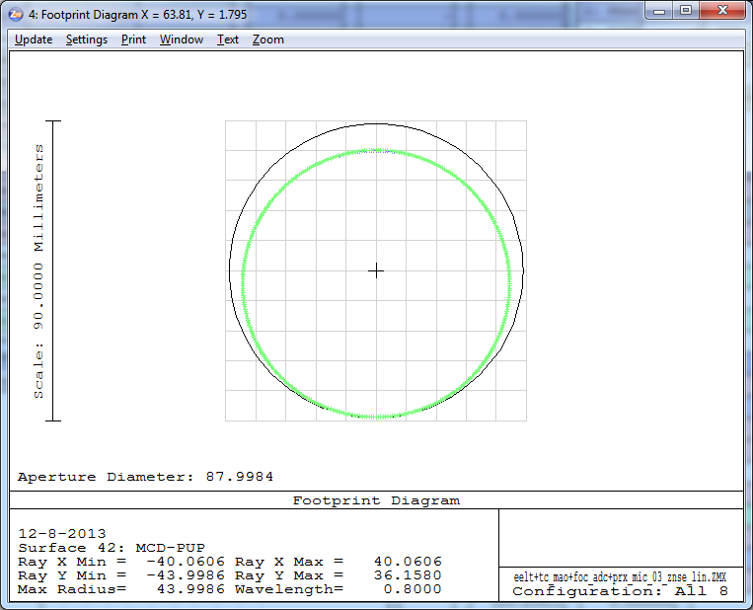  Figure 30 Pupil shear for 0.8 micron wavelength. The colors represent different zenith angles. | 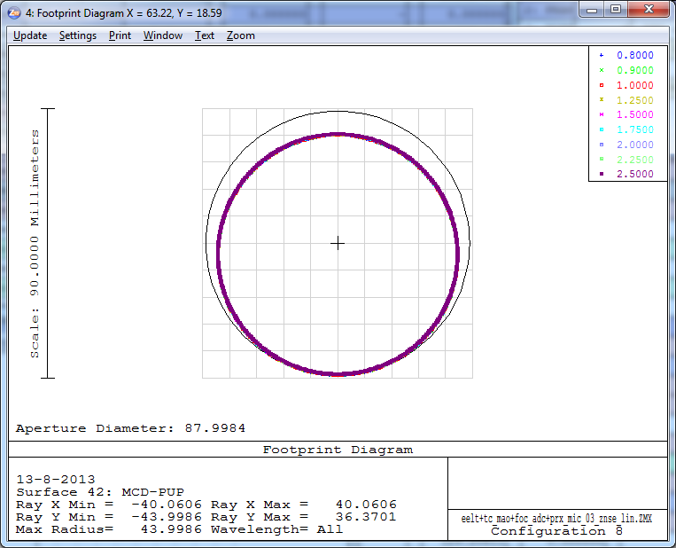  Figure 31 Pupil shear for 65 degrees zenith angle. The colors represent wavelengths between 0.8-2.5 micron.

Zero deviation linear ADC
In the following the ADC configuration from section 2.4. was re-optimized in order to reduce the spot drift in the focal plane. The maximum travel between the components was increased to 400mm to reduce prism top-angles. The prism materials are ZnSe and ZnS. S-NPH2 and SPINEL were also considered as materials, but the prism top angles and thus the prism sizes became extremely large.
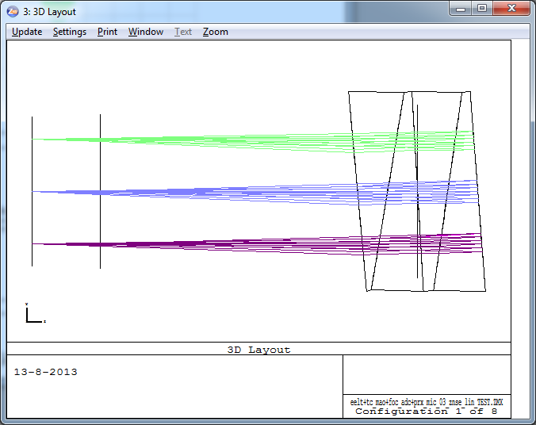  Figure 32 Layout of the linear ADC for zenith angle 0 deg. | 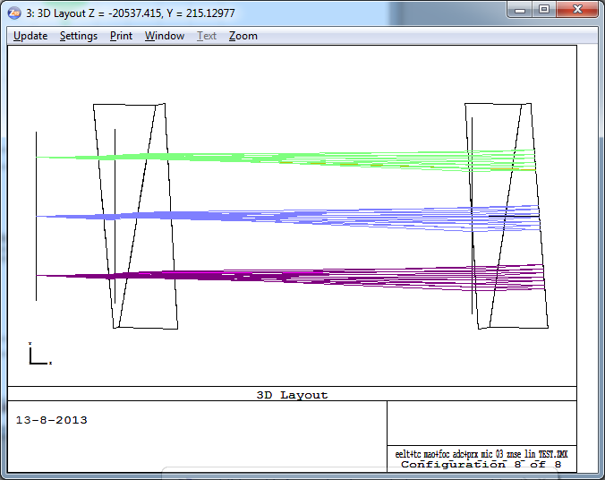  Figure 33 Layout of the linear ADC for zenith angle 65 deg.

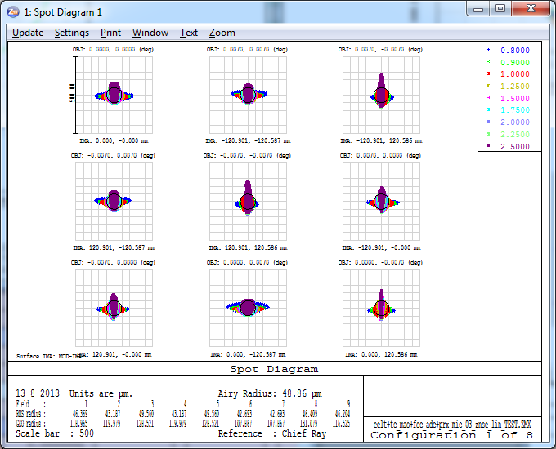  Figure 34 Spot diagrams for zenith angle 0 deg in the MICADO detector plane. Scale is 500 microns. | 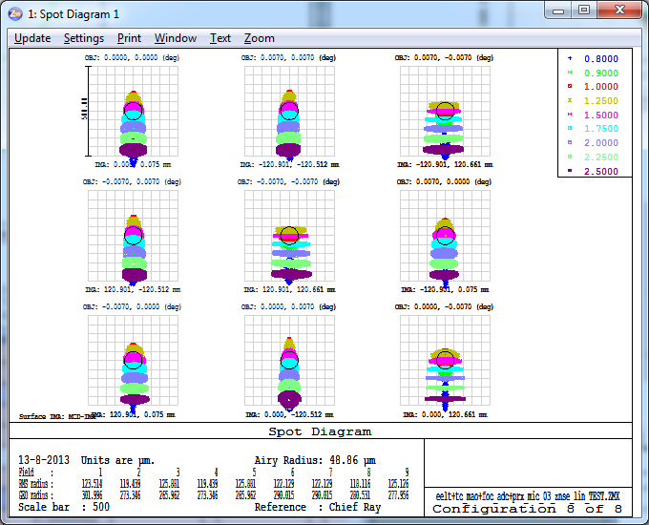  Figure 35 Spot diagrams for zenith angle 65 deg. Scale is 500 microns.
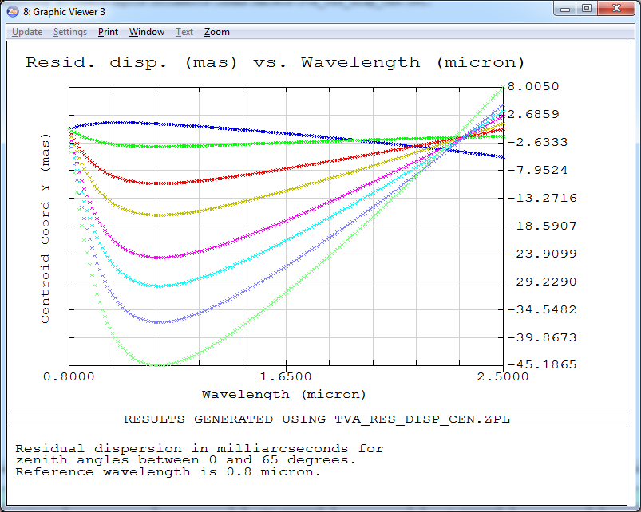  Figure 36 Residual dispersion in mas (PV is 53 mas) for the zenith angles 0, 15, 30, 40, 50, 55, 60 and 65 degrees. | 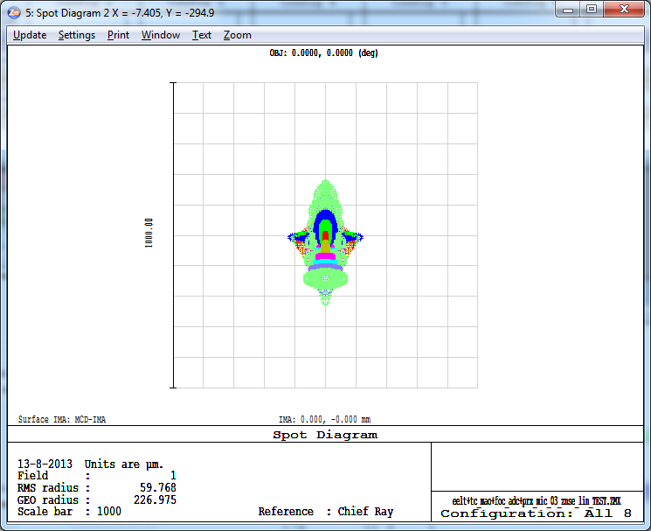  Figure 37 Spot drift is reduced completely as the ADC rotates. Spots for zenith angles 0, 15, 30, 40, 50, 55, 60 and 65 degrees are shown.
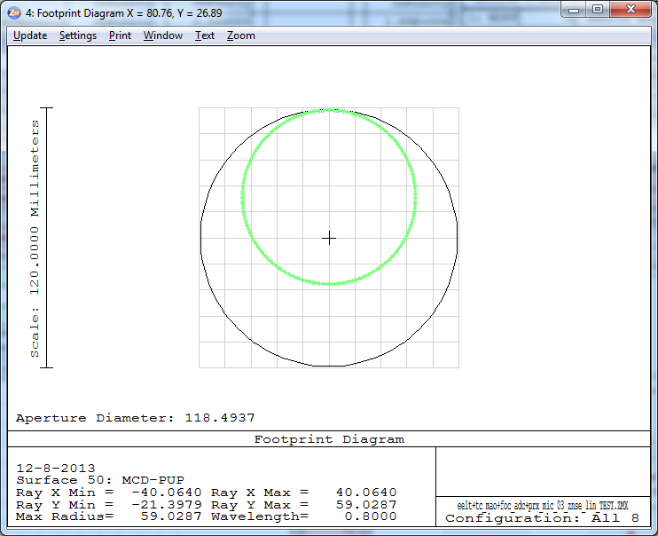  Figure 38 Pupil shear for 0.8 micron wavelength. The colors represent different zenith angles. The optical axis is tilted after the ADC, this is shown up as global pupil decentre. | 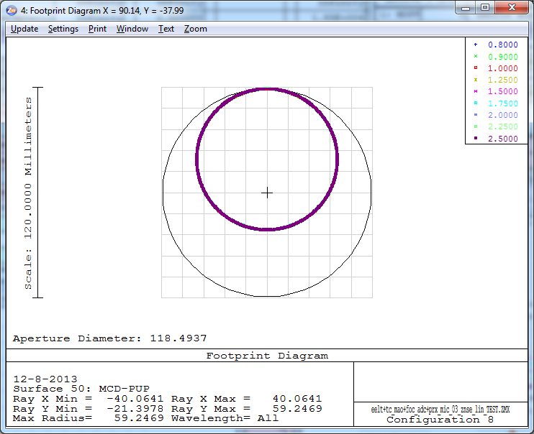  Figure 39 Pupil shear for 65 degrees zenith angle. The colors represent wavelengths between 0.8-2.5 micron.

Linear ADC with flat mirror
In the following the linear ADC is shown, when used together a 45 degree fold mirror that can be translated. With the translation of the fold mirror the spot drift in the focal plane can be compensated and only the defocus changes for the different configurations. In the following two figures the layout is shown first without the fold mirror, then with the fold mirror (in different positions). In principle any fold mirror currently present in the system can be used for this functionality, but due to the possible footprint increase the clear aperture of certain components have to be increased.
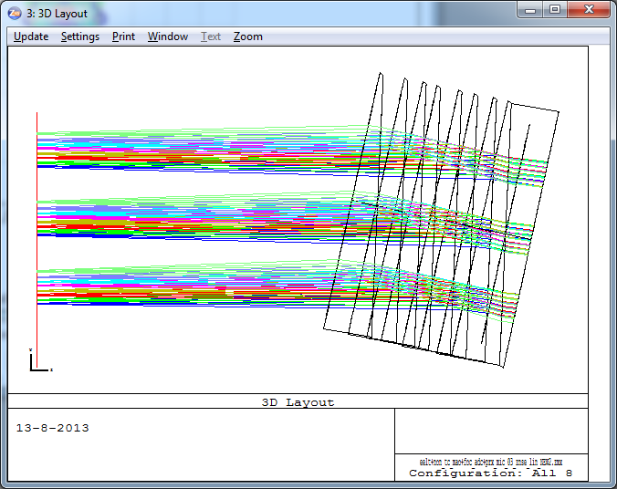  Figure 40 Layout without the fold mirror. | 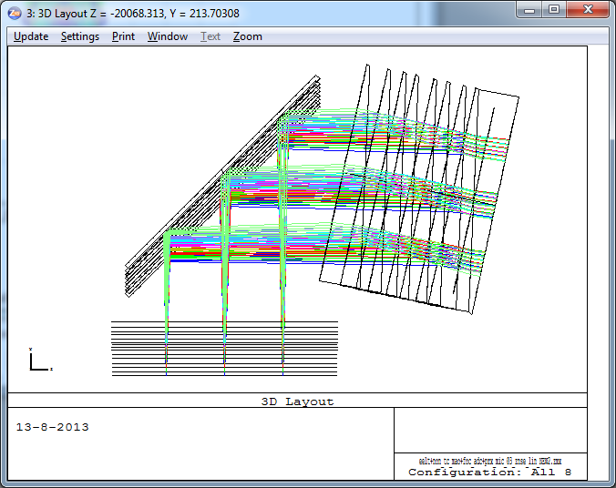  Figure 41 Layout with the fold mirror that can be translated in order to correct for the spot drift (additional defocus will be introduced).

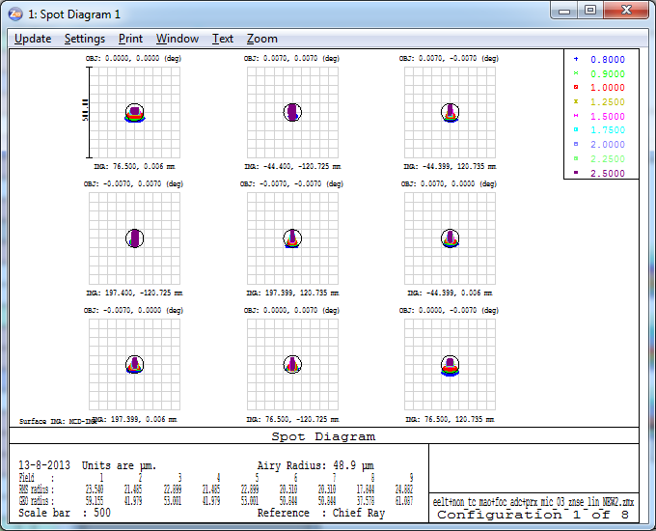  Figure 42 Spot diagrams for zenith angle 0 deg in the MICADO detector plane. Scale is 500 microns. | 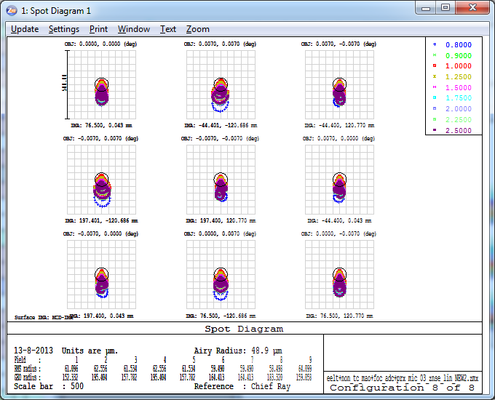  Figure 43 Spot diagrams for zenith angle 65 degrees. Scale is 500 microns.
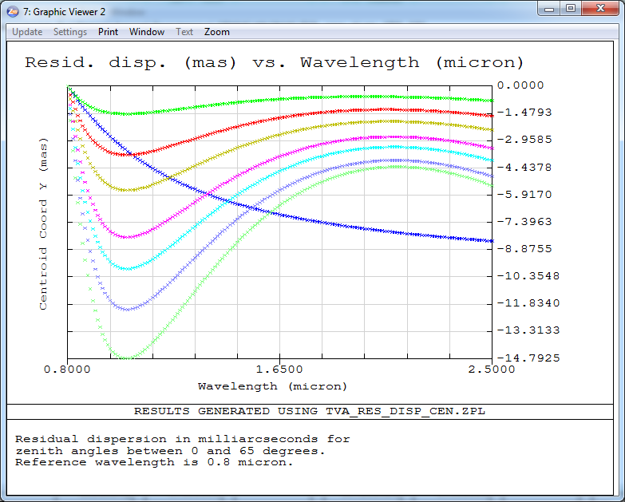  Figure 44 Residual dispersion in mas (PV 15 mas) for the zenith angles 0, 15, 30, 40, 50, 55, 60 and 65 degrees. | 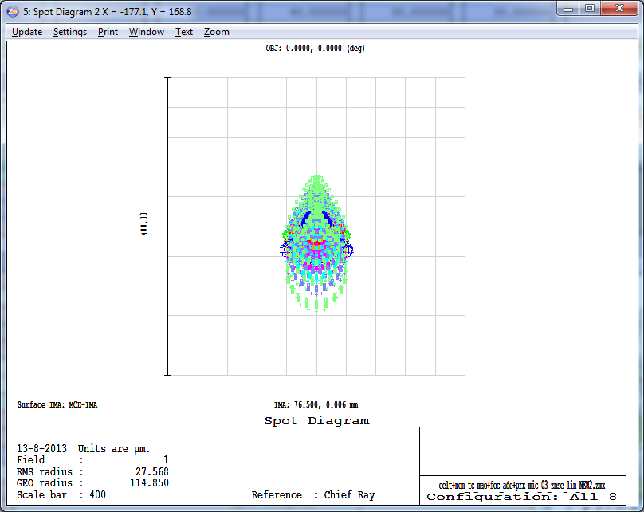  Figure 45 Spot drift is reduced completely as the ADC rotates.
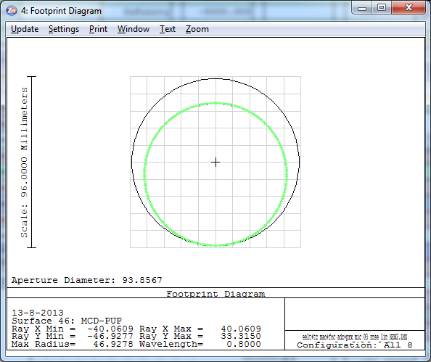  Figure 46 Pupil shear for 0.8 micron wavelength. The colours represent different zenith angles. | 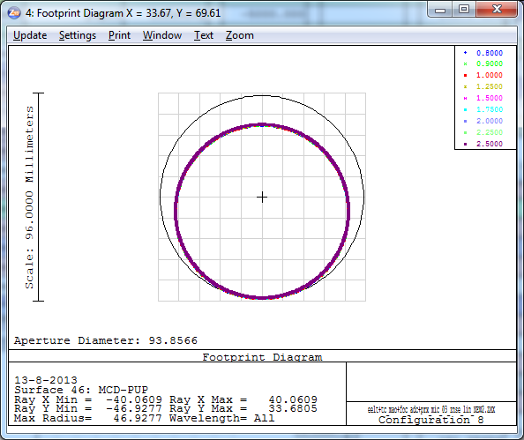  Figure 47 Pupil shear for 65 degrees zenith angle. The colours represent wavelengths between 0.8-2.5 micron.

Intermediate conclusions (focal plane ADC-s)
We investigated different ADC configurations that can be located before the focal plane of MICADO. We compared the phase A ADC, counter rotation based and linear ADC types. In the following table the characteristics of each ADC are shown.
Table 1 Comparison of the different ADC configurations. The values are colour coded for better visibility.
 | Phase A ADC* | Counter rot. ADC | Counter rot 0 dev. ADC | Linear ADC | Linear 0 dev. ADC | Linear ADC with flat mirror
Optical aberrations (micron) ** | 50 | 40 | 40 | 40 | 70 | 40
Residual dispersion in mas(0.8-2.5 µm) | 898 | 27 | 20 | 15 | 53 | 15
Spot drift in the MICADO focal plane in mm | 4 | 7 | 0 | 60 | 0 | 0
Pupil shear as a function of wavelength (%) | 5 | 12 | 4 | <0,1 | <0,1 | <0,1
Pupil shear as a function of ADC rotation (%) | 0,5 | 6 | 6 | <0,1 | <0,1 | <0,1
Space envelope  (+ small, - large) | + | + | + | - | -- | +/- ***
Refocus needed (mm) | <0,01 | <0,03 | <0,04 | 2,6 | 2,3 | 42,3
*With non-telecentric relay before MICADO.
**Worst monochromatic RMS spot radius for 65 degree zenith angle.
***Depending whether existing fold mirror can be used.

Different ADC types have different advantages and disadvantages. If generally speaking the pupil quality is of concern in MICADO, the linear ADC-s provide the best option, but then the spot drift in the focal plane have to be tackled in some way. An adjustable fold mirror can be a solution, but then the re-focusing range increases dramatically. A zero deviation linear ADC occupies a lot of space and also it introduces a significant optical axis tilt after the ADC. If the pupil quality is not that important, the counter rotation based ADC designs are more advantageous, especially the zero-deviation version.
In any case it is recommendable that a linear ADC design and a new counter rotation based ADC design are modeled the way it was done in phase A and compare the results.
The transmission of some components is not very good in some parts of the 0.8-2.5 micron spectrum, the transmission data of these materials is shown in the Annex. Also the optical performance of the ADC configurations is detailed in the Annex.
The telecentricity and non-telecentricity of the relay before MICADO does not have an effect on the ADC performance, except for the concept A ADC, which was designed for a non-telecentric pre-optics. Nevertheless the ADC has to be designed with the whole optical system known, otherwise naturally there will be an impact on performance (e.g. ADC designed for telecentric pre-optics will not perform well with non-telecentric pre-optics).

Detailed investigation of the two best ADC candidates
From the previous section the linear ADC was selected for a follow-up study. It is compared to a counter rotation based ADC located in the pupil of the SCAO system. This latter was not investigated until a very late stage because of the lack of information of the SCAO system. Finally the S-FPL51 and S-LAH71 material pair provided the best combination to mimic the atmospheric dispersion. They are also considered to be easier to manufacture than the ZnSe-ZnS and S-NPH2 and SPINEL pairs that were investigated before.
Both of the two selected ADC-s performs very well regarding pupil quality in the MICADO pupil plane (better than 0.1% pupil shear) and the residual dispersion is also very good compared to other ADC designs.

MICADO optical model
The paraxial model of the EELT, the SCAO system and MICADO were used to study the performance of the two ADC-s. At the time of the present study, there was not a tangible and unique optical design available and furthermore the performance of the ADC was ought to be separated from other optical effects of the optical path, so the paraxial model was decided to be used.
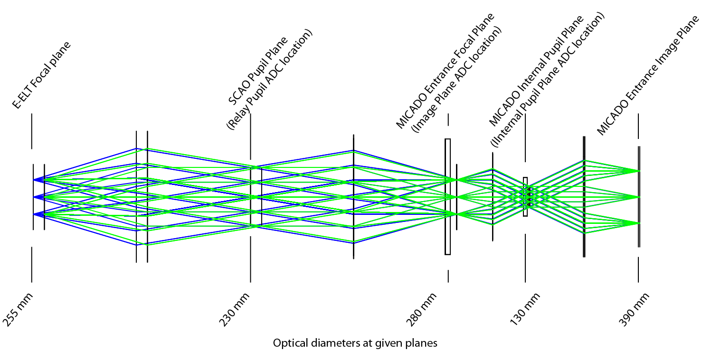

SCAO pupil plane ADC
The SCAO pupil plane ASC is a counter rotation based ADC. S-FPL51 and S-LAH71 are the two materials that have the best possible conjoint dispersion that is able to mimic the atmospheric dispersion in the 0.72µm - 2.42µm range. The ADC consists of two identical prisms that rotate against each other. When their orientations are the same, the maximum dispersion is introduced, when they are reversed with respect to each other their dispersions null each other out. The former state corresponds to the situation, when the telescope is pointing at the maximum 60 degree zenith angle and the later, when the telescope is at zenith. In the following the layout of the ADC is shown.
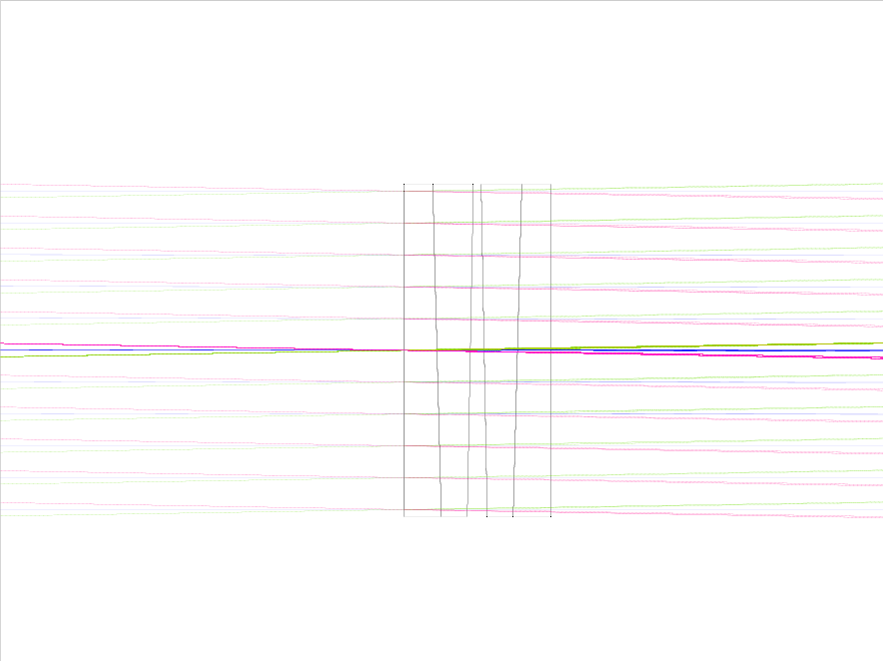
S-FPL51
S-LAH71
Figure 48 The layout of the SCAO pupil plane ADC. The diameter of the components is 240mm and the thickness at the vertex is 24mm.
The residual dispersion is very good, it is shown below for the total 0.72µm - 2.42µm range. Naturally this chromatic spread is much less, when only a smaller wavelength range is used.
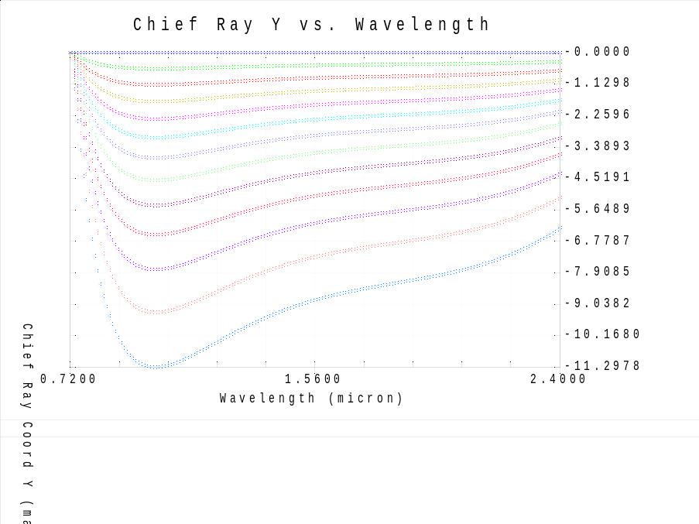
Figure 49 Residual dispersion is shown (PV 12mas). The different colours represent different zenith angles between 0 and 60 degrees.

The pupil shear was investigated inside MICADO and it was found to be almost perfect, definitely better than 0.1%. Both optical performance (residual dispersion) and MICADO pupil plane shear were evaluated at different pupil locations and it was found that they do not depend on the distance between the pupil and the location of the ADC. T
he transmission of the ADC materials is shown in the Annex.

MICADO focal plane ADC
A linear ADC in front of the MICADO focal plane is presented in the following. It consists of two identical ZnSe prisms, which form a plane parallel plate, when placed close to each other. This later scenario occurs, when the telescope is pointing at zenith; when the telescope is pointing at larger zenith angles one of the prisms is shifted away (towards the focal plane). In the design shown below the shift of the prism is 300mm. In the following the layout and the residual dispersion are shown for the linear ADC.
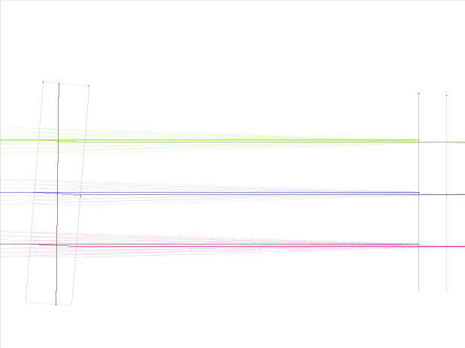  ZnSe | 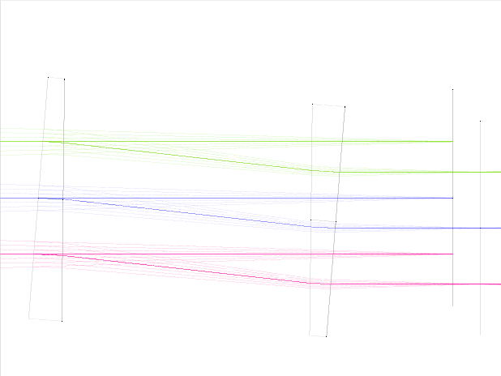
Figure 50 The linear ADC is shown, which is in the MICADO focal plane. The diameter and thickness (at the vertex) of the components are 300mm and 30mm respectively. Telescope is pointing at zenith (left), telescope is pointing at 60 degrees zenith angle (right). In the latter case the optical axis is decentered by 33.35mm.
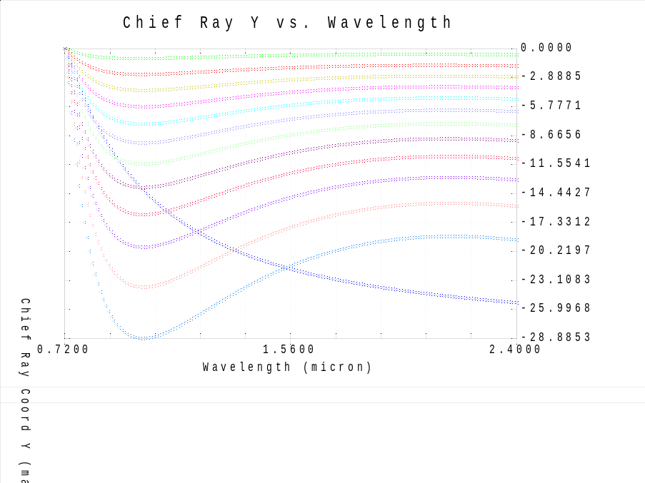
Figure 51 Residual dispersion is shown (PV 29mas). The different colours represent different zenith angles between 0 and 60 degrees.

Tolerances
The tolerances of the two systems were investigated and the worst offenders were identified. Using the residual dispersion as a criteria in the tolerance analysis, the tolerances on the homogeneity and the surface irregularity are the worst offenders. After the blanks are made, the re-optimization of the prism top angles is necessary knowing the material properties of the blanks.

Manufacturing tolerances investigated:
- Thickness, decentre x,y: 20 micron
- Surface tilt and component tilt:
  - 0.0048 deg (20 micron over the full diameter) for the pupil ADC
  - 0.0038 deg (20 micron over the full diameter) for the linear ADC
  - 0.0024 deg for the pupil ADC as unit
  - 0.0019 deg for the linear ADC as unit
- Index: 0.001
- Abbe: 0.1 (index and Abbe should be measured and them tits are re-optimized)
- Surface irregularity:
  - 10nm (pupil ADC)
  - 15nm (linear ADC)
- Homogeneity
  - ZnSe 4ppm
    - it means a +/-2ppm variation (H3 equivalent), with a 30mm thickness It is 30nm RMS WFE
  - S-FPL51 and S-LAH71 2ppm
    - it means a +/-1ppm variation (H2 equivalent), with a 24mm thickness It is 12nm RMS WFE
- Birefringence <=10nm/cm
  - it means a 24 nm RMS WFE
- Stria grade A
  - it means <15nm RMS WFE
- thickness, diameter of blank: +/-0.5mm

ADC optical models analyzed
An overall four configurations were analyzed in detail. For each of them the adjustable parameter (counter rotation and translation of the linear ADC respectively for the two designs) was re-optimized for the I, J, H and K bands.
ADC design | ADC type | Tolerances
SCAO pupil ADC | Counter rotation based | No tolerances
SCAO pupil ADC | Counter rotation based | Worst case tolerances
MICADO focal plane ADC | Linear ADC | No tolerances
MICADO focal plane ADC | Linear ADC | Worst case tolerances

A 10000 sample based Monte Carlo simulation was run using the above indicated tolerances. The tolerances followed a parabolic distribution, which yielded selected values that were more likely to be at the extreme ends of the tolerance range, rather than near the middle, as for the normal distribution. The worst samples of this Monte Carlo simulation were selected for further study presented below.
In the following the spot diagrams (also showing the nominal image quality) and the residual dispersion is shown for these worst case scenarios.
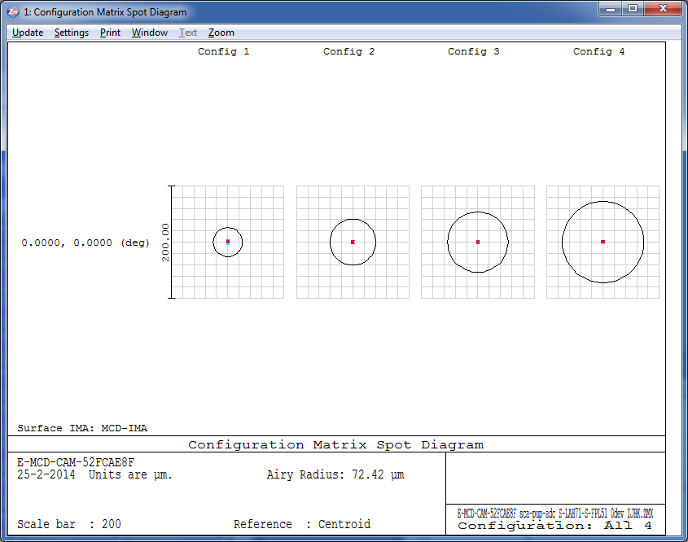
Figure 52 Spot diagrams for the I, J, H and K bands for 60 degrees zenith angle for the nominal case of the pupil ADC. The Airy disk for each band is shown for the smallest wavelength.
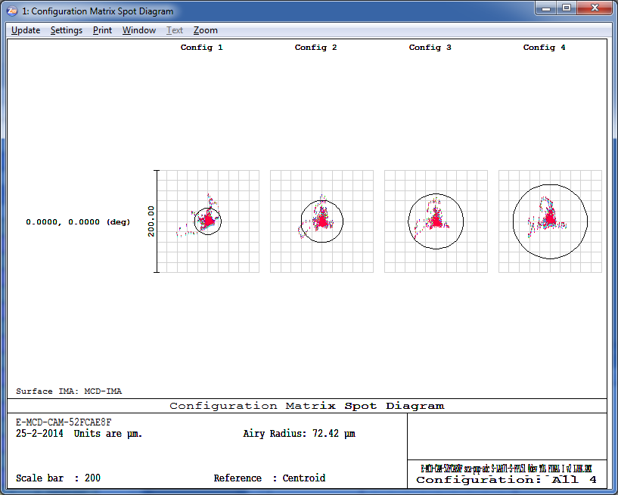
Figure 53 The same as in the previous figure but for the toleranced pupil ADC.
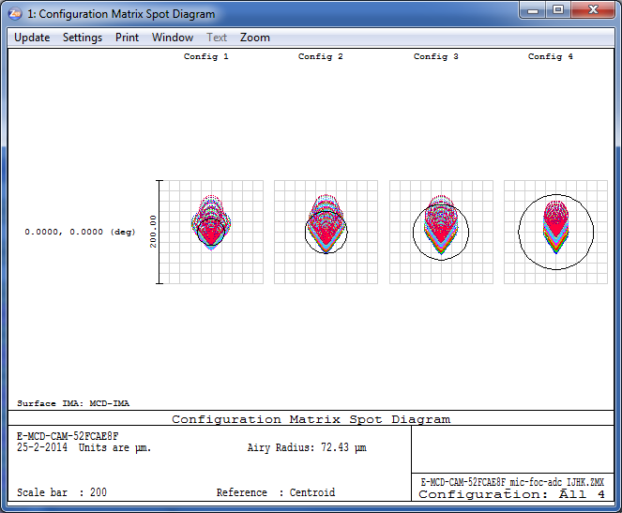
Figure 54 The same as in the previous figure but for the nominal linear ADC.
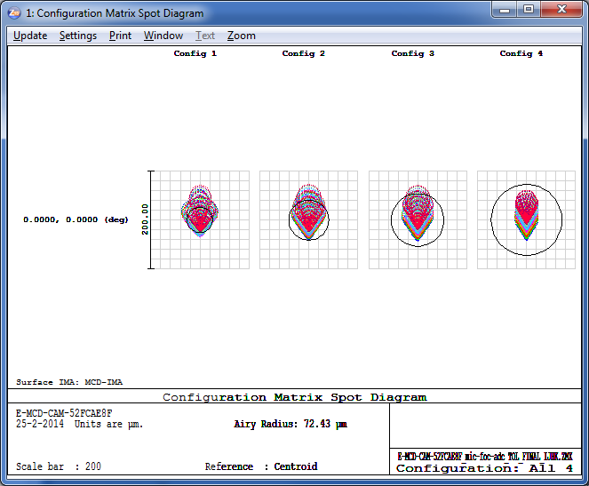
Figure 55 The same as in the previous figure but for the toleranced linear ADC.
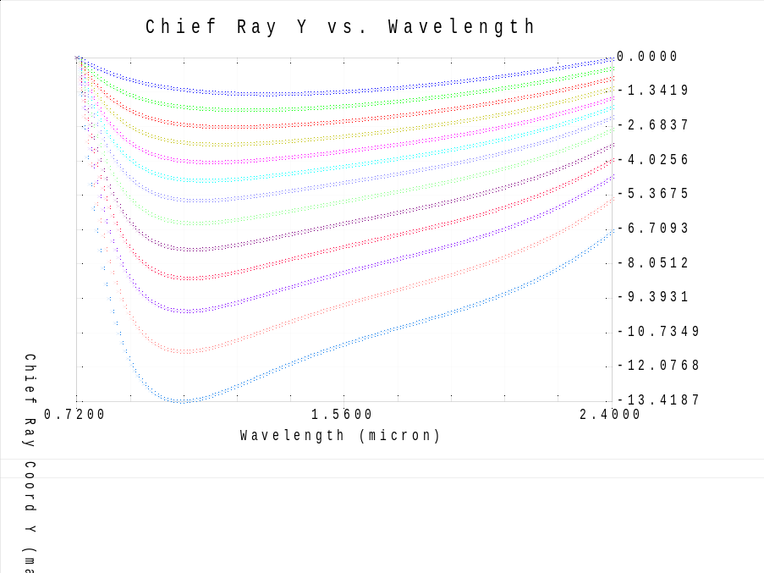
Figure 56 Residual dispersion is shown (PV 14mas) for the toleranced case of the pupil plane ADC.
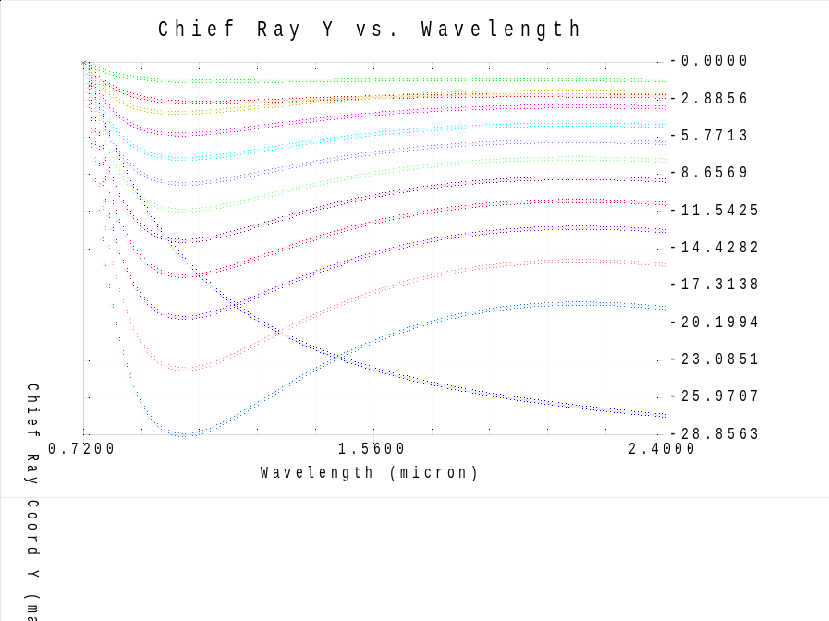
Figure 57 Residual dispersion is shown (PV 29mas) for the toleranced case of the linear ADC.

Thermal considerations
One of the concerns that has been raised is the thermal stress introduced by variations in temperature between manufacturing and operation. Apart from survivability during transport, there are three scenarios that could be envisioned:
- Operation at observatory standard conditions, i.e. 280K+-6.5 degrees
- Operation at observatory stabilized conditions, i.e. 280K+-0.1 degrees
- Operation at MICADO cooled temperatures, i.e. ~100K+-0.1 degrees
Assuming that the ADC can be integrated at observatory-standard conditions, the following table gives an overview of the relative and absolute differences in expansion between the two components of a pair of materials, based on the material properties given in APPENDIX QQQ.
<<insert table with relative expansion for above three cases>>
Although no full FEA over the temperature ranges has been performed, it can be clearly seen that the difference in expansion between two materials will most likely lead to unacceptable stresses in any solidly cemented ADC when cooled to cryogenic temperatures. Since no known index-matching fluid exists that remains its flexibility down to cryogenic temperature, this means that the ADC needs to be constructed from independent components, adding to the complexity of the system and effectively doubling the number of surfaces of the ADC.

Conclusion on ADC selection
We investigated different ADC configurations that can be located before the focal plane of MICADO and in the pupil plane of the SCAO system. We compared counter rotation based and linear ADC types.
We identified the two best ADC designs and analyzed them. It became apparent that, when looking at the nominal systems, the pupil ADC performs better, but when real tolerances are also modelled, the difference diminish between the two systems.
The manufacturing tolerances are thought to be very tight by the manufacturers and further study is recommended to find the best trade-off between the manufacturing tolerances and the performance of the system.

Simulations [Remko/Gijs/John]

AO Simulations and Analysis [Remko]

AO simulations from LESIA
In order to investigate the effects of the SCAO system on we have started collaborating with Yann Clenet from LESIA, who is currently responsible for the SCAO simulations for MICADO. These simulations are stochastical simulations of the atmosphere, simulating the propagation of light through a turbulent atmosphere (with several layers), computing the required wavefront correction and applying this correction to achieve closed loop performance estimates. These simulations include:
Effect/Property | Included
Telescope Dimensions | 38.5 m, f/17.48, secondary obscuration, spiders
Simulation Wavelength | Free to choose – phase maps at 2.2 micron provided
Guide Star Wavelength | NGS, 450-720 nm  atmospheric dispersion not(?) included
Guide Star Brightness | Bright (i.e. V < 5)
Atmosphere | Standard Paranal atmosphere  r₀ = 0.129 m  Mean wind speed 14.5 m/s
Field angles | On-axis & simultaneous set of 5” + 10”
Wavefront sensor | Shack-Hartmann  77x77 sub-apertures  4x4 pixels per sub-aperture
Closed loop frequency | 1 kHz
Zenith Angle | 0 degrees

The following effects were NOT included:
Effect/Property | NOT Included
Telescope Dimensions | Segment errors  Segment gaps  Vibrations  Pupil misalignment
Atmosphere | Atmospheric composition variations
Field angles | Simultaneous on-axis off-axis data
Closed loop frequency | Loop delays (?)
Instrument | Distortions  Optical properties of the relay  Non-common path errors  Slowly varying wavefront errors, other than atmospheric (persistent speckles)

Simulation data are provided as residual phase maps. This allows for a full reconstruction of the PSF at any desired wavelength. In order to reduce the data volume, only 1 of every 1000 phase screens are provided, i.e. at a sampling of 1 second. For the on-axis data, we have access to 1 hour of data (~26 Gb), while for the off-axis data we have 1000 seconds (18 Gb) of parallel datasets for 5” and 10” away from the guide star.

Transforming simulations into images
The output images are made to match the central CCD of MICADO and has the following properties:
Property | Value
CCD Type | Hawaii-4RG  4096 x 4096 pixels  15 x 15 micron per pixel
Quantum Efficiency | CCD: 100% or supplier delivered  Atmosphere: 100% or atmospheric  Stellar Spectrum: 1.0 (not included)
Noise | 10 ADU nominal noise, only added to provide something noisy for SEXTRACTOR  NO photon noise, dark current, read noise or other noise source are currently added.
Bias | 1000 ADU, , only added to provide something quasi-realistic for SEXTRACTOR
Digitization | 16 bit
Stellar Brightness | Set to provide maximum 60,000 ADU on CCD
Exposure time | 0.001 – 100 seconds
Pixel scale | 0.003”/pixel
On-Sky CCD size | 12.3” horizontal/vertical  17.2” diagonal
Stacking Procedure | Straight sum (as if single exposure!)

In order to provide images for the correct wavelength, and in later stages, to introduce distortions, the following steps are applied for each wavelength and position in the field, to transform each phase map to an image:
- The phase screen is scaled and zero-padded to provide an image with a pixel scale of 3 mas per pixel over 4096x4096 pixels.
- Sub-pixel shifts of the PSF are computed by adding a phase slope is to the phase screen. These sub-pixel shifts can include deviations depending on position and wavelength, and can be time-variable.
- The PSF is computed by a Fast Fourier Transform.
- The PSF is shifted by integer pixels to the correct location in the field (sub-pixel shifts were already applied).
- A diffraction limited PSF is computed, based on a telescope pupil with no wavefront distortion. Since this PSF is computed in the same way as the distorted PSF, it allows for a calibration of the Strehl ratio and sanity check on the expected FWHM of the PSF as a function of wavelength.
- The PSF is normalized, either by Strehl or integrated flux and added to the sum image.
- The sum-image is normalize to reach a maximum of 60000 counts, bias and noise are added. Note
A full simulation performed this way takes approximately 5 seconds per image, per star, which already gives an indication that performing the simulation in this way is not suitable for a full simulation of a dense stellar field, nor long exposures, nor a large variation in parameter space.

Relative astrometry on simulated images [John/Gijs]
We have investigated the accuracy in relative astrometry that can be obtained on the simulated images.
We analyzed the series of single exposure images (“snapshots”) and the series of stacks of 2 time-adjacent exposures (“2-stacks”) and (similarly stacked) series of 4-stacks, 5-stacks, 10-stacks, 20-stacks, 50-stacks and 100-stacks.

We took advantage of the existing Astro-WISE infrastructure to produce and store the results, catalogs and pixeldata for the set of simulations (currently approaching 1700 images and growing). Links to the data archive are given in Table 6.1.
Set | Simulated images | Sourcelists
3sec sampling | Error! Hyperlink reference not valid.  Error! Hyperlink reference not valid.  4-coadds  5-coadds  10-coadds  20-coadds  Error! Hyperlink reference not valid.  50-coadds  100-coadds | For:  snapshots  2-coadds  4-coadds  5-coadds  Error! Hyperlink reference not valid.  Error! Hyperlink reference not valid.
1sec sampling | Error! Hyperlink reference not valid.
Table 6.1

Source extraction and centroiding
The simulated exposures contain a background with a gaussian noise of mean of 1000 ADU and sigma of 10 ADU. The two stars have peak pixel values approaching 60000 and 45000 ADU, have total fluxes of ~1E6 ADU in the central 200-300 pixels and do not contain poisson errors. Thus their formal S/N>5500.
For a well-sampled PSF the limit to centroid measurement accuracy sigma_c_m is (e.g., Kuijken et al 2012):
- sigma_c_m ~0.7 FWHM / (S/N)
which for our simulated images translates to sigma_c_m = 1 micro-arcsec for star at 2.2 micron.
However, there could be an additional systematic error in centroiding due to:
- the speckled, not well-sampled PSF in individual snapshot which smooth out for stacked exposures (see Fig. 6.1). Due to this Sextractor detects a varying number of spurious sources in the wings of the PSFs in single snapshots. However, the central detection is dominant in terms of flux (contains at least ~5 times more flux than any other source). In sufficiently (≥10) coadded images the spurious detections are absent.
- basic centroiding: we extract sources using SExtractor measuring the position in two ways: the barycenter of the isophotal footprint and Gaussian fit to the flux distribution (i.e., X_IMAGE and XWIN_IMAGE).

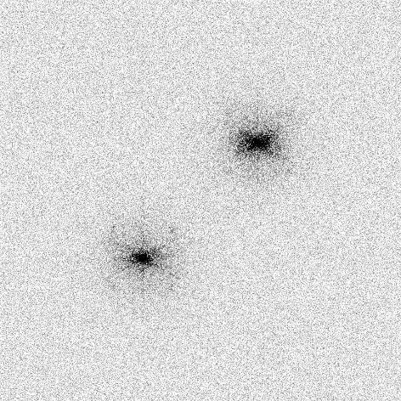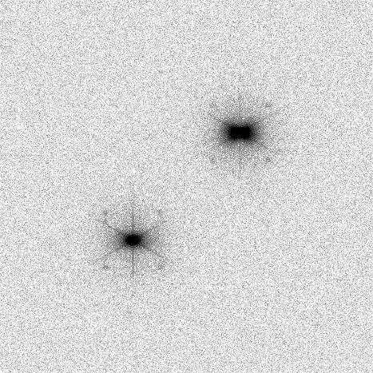
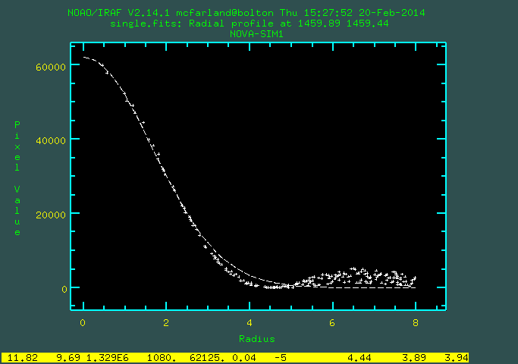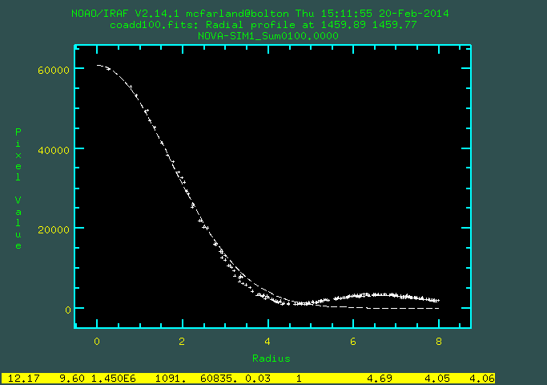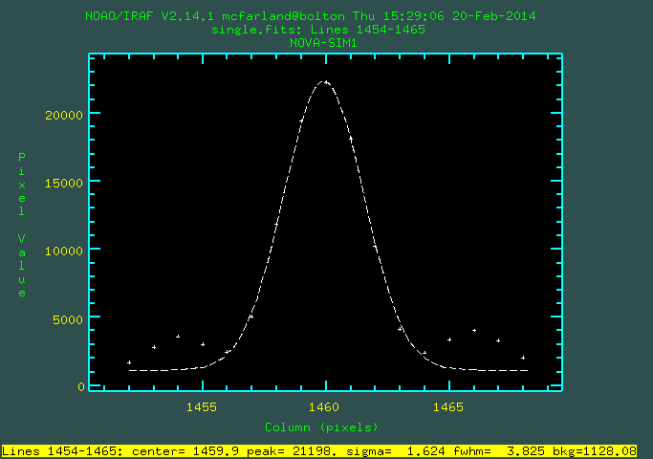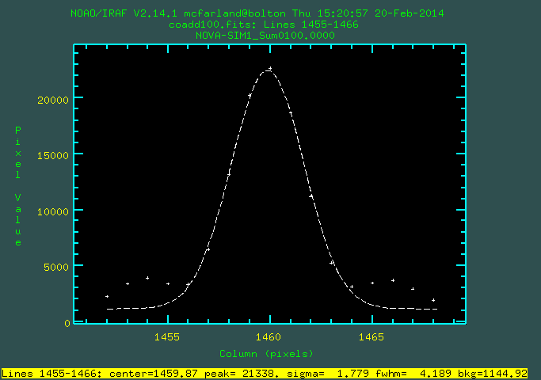
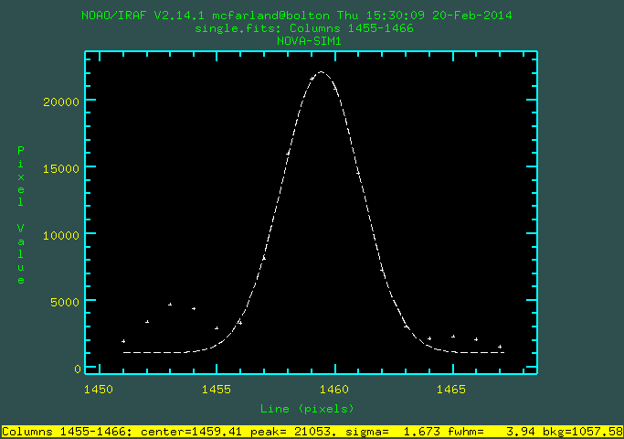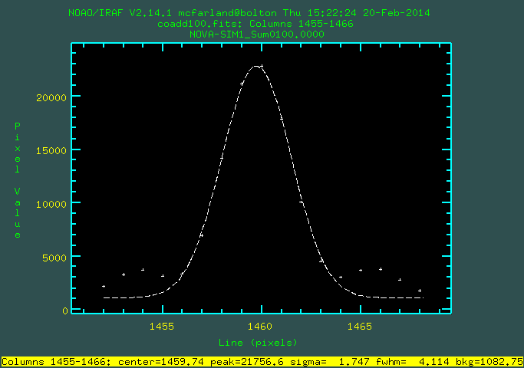
Figures 6.1 Images and their radial and profile plots (IRAF imexamine) of a single snapshot exposure (left) and 100 stacked snapshots (right).

We use the following information from the source extractions:
- Position measures:
  - X_IMAGE/Y_IMAGE, ERRX2_IMAGE/ERRY2_IMAGE = barycenter (flux-weighted first moment) and their error (1sigma)
  - XWIN_IMAGE/YWIN_IMAGE = Gaussian windowed measurement of these parameters
- Profile measures:
  - FWHM_IMAGE (assuming gaussian profile)
- Flux measures:
  - FLUX_APER: flux inside a 25 pixel diameter aperture.
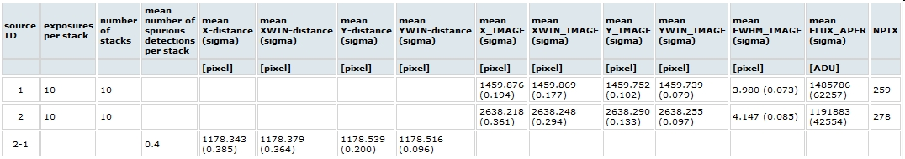

Table 6.1. Statistics of extracted source parameters for the sets of stacks of 2,4,5,10 and 20 exposures. Averages and standard deviations are listed for most parameters. Description of parameters is given in the text.

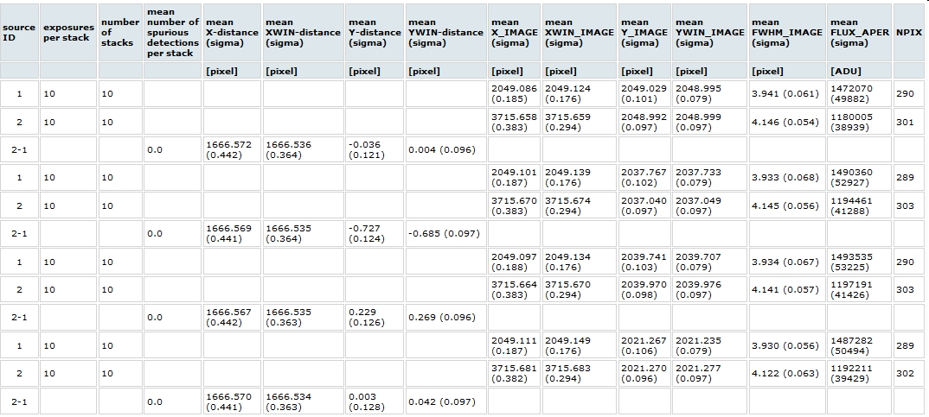

Tables 6.2 and 6.3. Basic information on source extraction and source distances for the 2 sources in the simulated images. Source 1 is 5arcsec away from the AO star in the X direction and source 2 10 arcsec. Both sources have same Y position as the AO star. Information is shown based on the 10 stacks that each contain 10 snapshot exposures. Top table (6.1) lists the information for the simulated images without ADC and bottom table (6.2) for the pupil plane ADC. The parameters are defined in the text.
The barycentric centroiding and Gaussian fit yielded similar results. X and Y positions typically agreed within 0.05 pixels. Distance measurements with the Gaussian fit had a slightly lower scatter (see Tables 6.2 and 6.3). In any further analysis we therefore discuss only the Gaussian fit results.

Results
In all images the sources have a FWHM ~ 4 pix (12 mas), i.e., close to the diffraction limited of 13 mas at 2.2 micron. The fact that it is slightly smaller could be due to the fact that the extraction does not identify the full wings of the profile as part of a single source.
The difference in peak values (60000 ADU for the source at 5arcsec from the AO star and 45000 ADU for the source at 10 arcsec) is expected due to anisoplanatism (e.g. Trippe et al.)
Tables 6.1 and 6.2 shows the distance measurements are very similar for the simulations with and without ADC. They also show that the scatter in the centroid is anisotropic: it is a factor 1.5-2 higher in the X direction compared to the Y direction. This is consistent with the anisotropy expected for tilt jitter (e.g., Trippe et al, 2010)

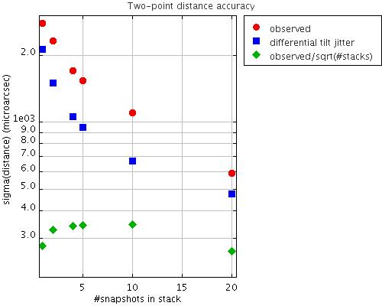
Figure 6.2: Standard deviation in microarcsec of distance measurements measured in single snapshots and in stacks of 2,4,5, 10 and 20 exposures. The observed standard deviation of the ensemble is shown (red circles) and the standard deviation divided by sqrt(#stacks) that contain a 100 snapshots in total (green diamonds). The prediction for the effect of differential tilt jitter is also shown (blue boxes).

We want to determine if there is a systematic floor to the accuracy with which we can determine the distance between the two stars. In Fig 6.2. the red circles show that the standard deviation of the distance measurements across series of different stacks (consisting of 1, 2, 4, 5, 10 and 20 exposures) scales roughly as 1/sqrt(#exposures). All stacked combinations of the 100 single exposures give a similarly accurate estimate of the distance with a standard deviation of ~300 microarcsec (shown as green diamonds).

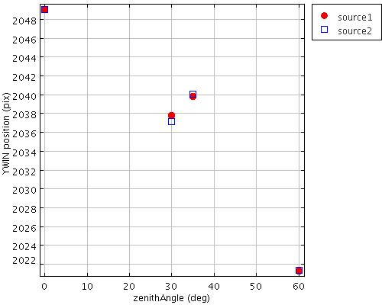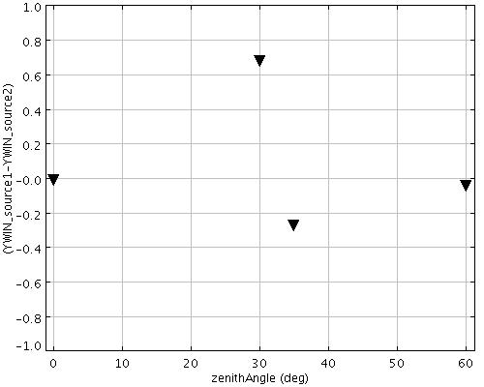
Fig.6.3. Position of the sources along the North-South direction ( Y direction) for the simulations that include an ADC. Left: Y position as a function of zenith angle for the source at 5arcsec from AO star (red circle) and source at 10arcsec (blue square). Right: difference in the Y position of both sources as a function of zenith angle.

It is the Y position of the sources that changes for the simulations with an ADC included. Both sources have intrinsically the same Y position which measures their position in the North-South direction. Fig. 6.3 shows that both sources show a variation in their position along North-South of up to 20 pixels moving from zenith to zenith-angles of 60deg. The relative difference in this position variation between the sources is up to a significant fraction from a pixel. **WHY IS THE 35DEG POINT SO DEVIANT FROM THE REST??: physics or something wrong?**.

Discussion
We observed a 1/sqrt(#exposures) decay in scatter in relative two-point astrometry. It has diminished to an amplitude of 300 micro-arcsec for Nexp=100 exposures. Such a behavior is expected for both main sources of astrometric error included in the simulations and their analysis: differential tilt jitter and random centroiding errors (Table 6.3). For differential tilt-jitter it is the wind crossing time on which exposures are expected to become statistically independent samplings. For centroiding errors the time scale is not known but might be on the time-scale of AO feedback loop.
Source of astrometric error | Comments
Differential tilt jitter σ_{TJ} | σ_{TJ} ~ θ * D^{-7/6} * (τ/t)^{1/2} , with θ angular distance between souces, D telescope diameter, τ wind crossing time and t integration time
Centroiding errors σ_{cen} | σ_{cen} ~(τ/t)^{1/2} with τ time-scale for statistically independent centroidings and t integration time

Table 6.3 Sources of astrometric error which are expected to be the main contributors (e.g., Trippe et al., 2010) for the discussed simulations
The associated timescale τ at which the exposures become statistically independent is not directly constrained by current simulations. This is due to the ambiguity whether the snapshot are representative for 1s exposures or less than that. Each snapshot has an exposure time of 0.001s while the ensemble samples the atmosphere at 1s time intervals. Fig 6.2 shows the predicted differential tilt jitter assuming the snapshots are representative of 1s exposures. Differential tilt jitter has as time scale the wind-crossing time which is τ ~ 3s in our case. The astrometric scatter predicted from tilt jitter only constitutes ~50 - 70% of the total observed astrometric scatter. Another contribution might come from e.g., centroiding errors. In this case the relevant time-scale could be as short as few milliseconds, which is the timescale on which the feedback loop for AO operates which causes moving speckles that might affect the centroiding.
To achieve a 35 micro-arcsec accuracy on a single baseline (i.e., distance between science object and a reference object) the simulations imply a required integration anywhere in the range from few tens of seconds to ~1.5hr. This would yield a ~25micro-arcsec final accuracy for science cases in which a single science object has many baselines with reference sources at a typical distance of ~5arcsec.
Simulations with and without ADC show very similar results except for the Y-position which measures the North-South direction. More extensive simulations are needed to determine how well the ADC residual effects can be corrected for with calibration software. From this single baseline and few zenith angles it cannot be determined if such variations are smooth and deterministic enough to be mapped by e.g., a polynomial or look-up table.

Conclusion
The current simulations do not find a showstopper to achieving 50micro-arcsec astrometry within a single night with MICADO. Once the MICADO design becomes more fixed it is possible to move forward from the current basic simulations to ones that take into account the full range of sources of astrometric error listed in Table XX. That is needed to confirm that 50 micro-arcsec astrometry is feasible in the end-to-end system of MICADO on the E-ELT

Next steps

Time-continuous simulations are required. This will alow to to disentangle effects due to centroiding errors and differential tilt jitter.

Expand simulation to include many baselines, varying in distance and orientation wrt AO star and wrt North. This to establish the scaling of the accuracy with baseline size and orientation. It shall also show to which extend systematic astrometric residuals due to ADC can be corrected for via calibration software.
Expand simulations to include all sources of astrometric error. Esp. instrumental geometric distortion are potentially dominant sources that need to be quantified thoroughly.
Expand few-wavelength simulations to full passband simulations. This will allow to include realistic spectral energy distributions.

ADC Simulations [Remko]
<Extension of first part of this study, explain plots>

Simulation plots

 | Image Plane ADC  Scale = 1·10⁵ micro arcsecond | Pupil Plane ADC | New IP ADC | New PP ADC | New Lin ADC
I | 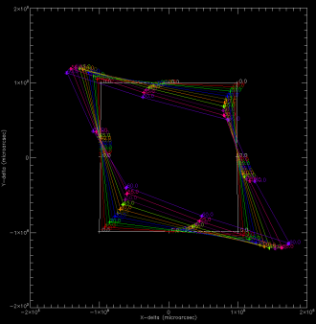  0  0 | 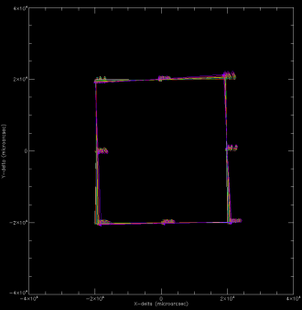  Scale = 2·10⁴ micro arcsecond  0  0 | 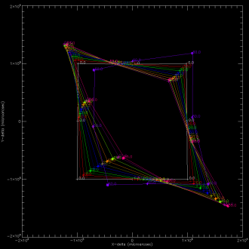  Scale = 2·10⁴ micro arcsecond  Scale = 1·10⁵ micro arcsecond | 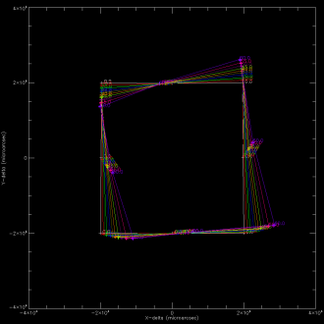 | 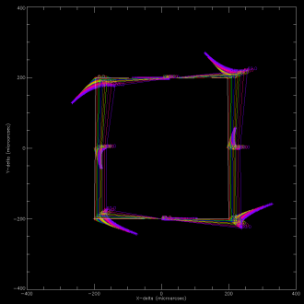  Scale = 2·10² micro arcsecond
J | 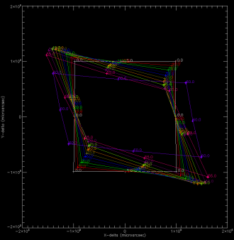 | 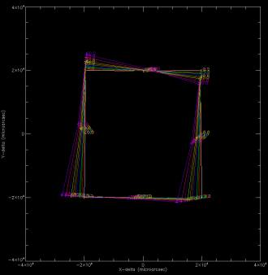 | 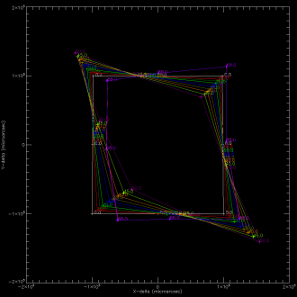 | 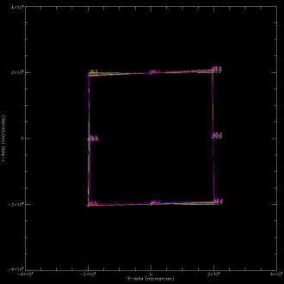 | 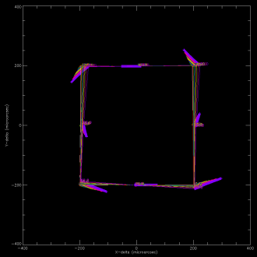
H | 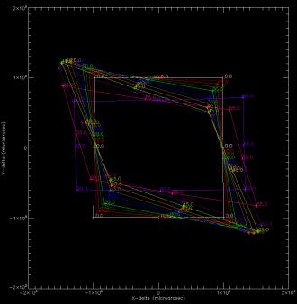 | 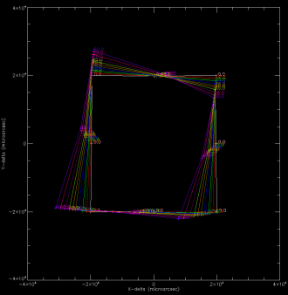 | 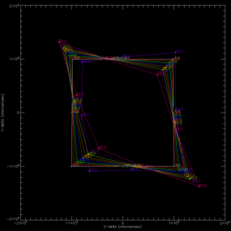 | 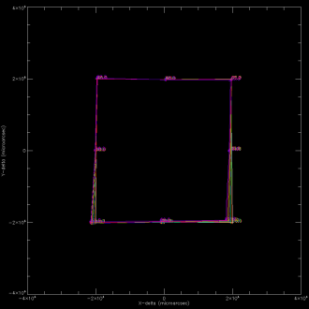 | 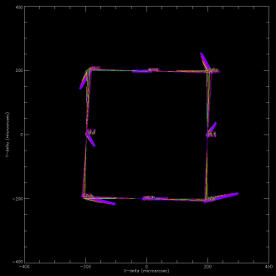
K | 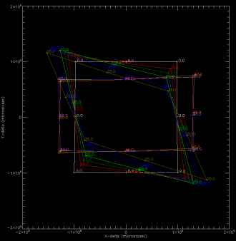 | 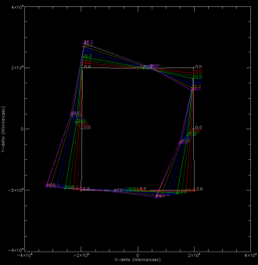 | 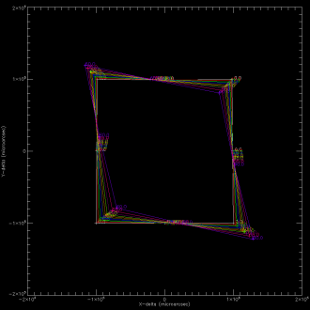 | 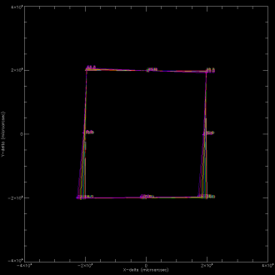 | 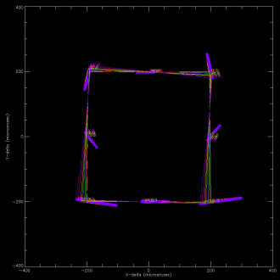
Figure 58. In the above 8 plots the difference in distance between image center and 8 edge of the MICADO field points are shown. What is shown is the relative distance variation between these points at zenith distance of 0 and given zenith distance (up to 60 degrees, given by different colors). For reference, the zero-position is given as a square, i.e., the distortion at the upper left corner for I-band at 60 degrees is Δx = -5000, Δx = +1000 with respect to the center position. From top to bottom the different bands are shown: I, J, H and K-band. The plots at the left are for an image plane ADC, the plots at the right for a pupil plane ADC. Notice the difference in scale! The scale is 1·10⁵ for the Image plane ADC, which is five times larger than the scale of 2·10⁴ for the Pupil plane ADC. The points on the square are the renormalized field positions. The distortions increase if the Zenith Distance increases. Distortions are expected to be low order, but are more complex than just a field rotation and magnification in X and Y.

 | Image Plane ADC  ZD=15°  ZD=10°  ZD=5°  ZD=0° | Pupil Plane ADC | New IP ADC | New PP ADC | NEW Lin ADC
I | 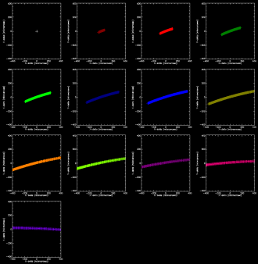  Scale = 400 micro arcsec  ZD=60°  ZD=55°  ZD=50°  ZD=45°  ZD=40°  ZD=35°  ZD=30°  ZD=25°  ZD=20° | 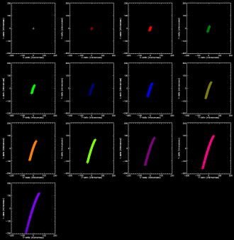  Scale = 200 micro arcsec | 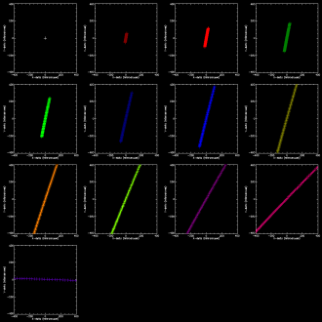  Scale = 400 micro arcsec | 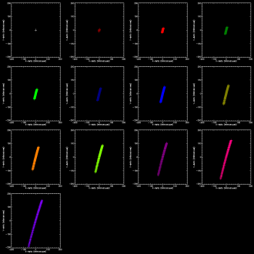  Scale = 200 micro arcsec | 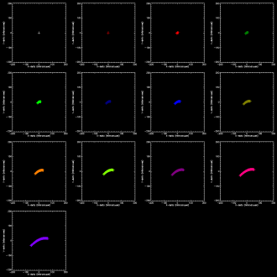  Scale = 200 micro arcsec
J | 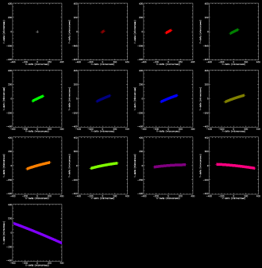 | 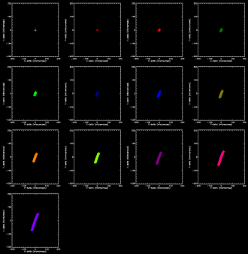 | 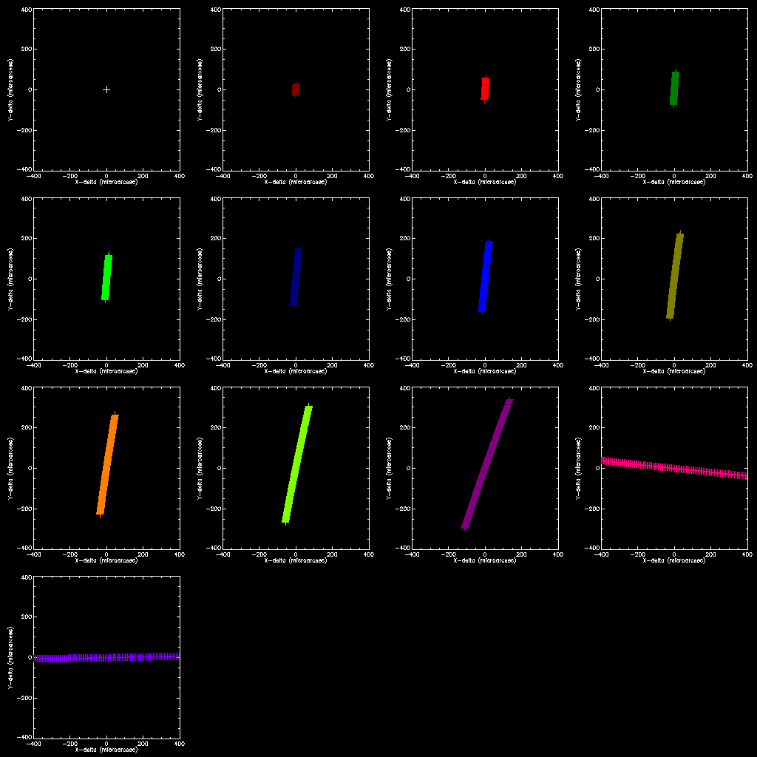 | 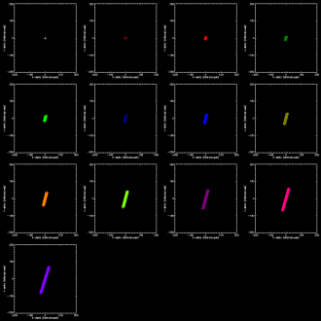 | 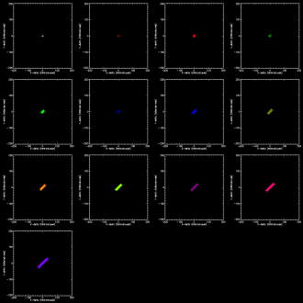
H | 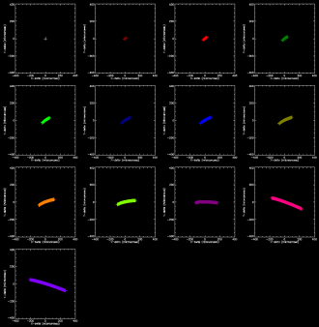 | 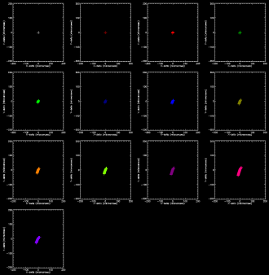 | 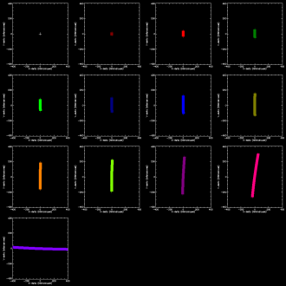 | 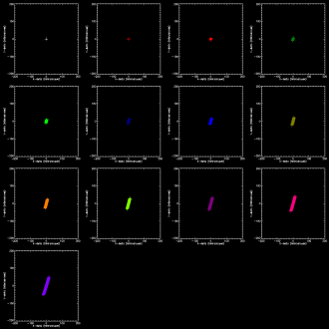 | 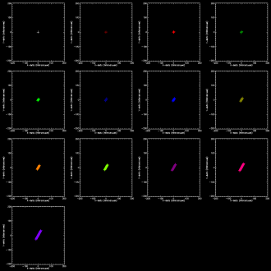
K | 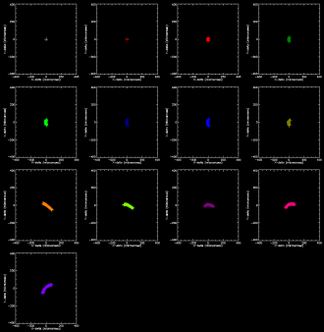 | 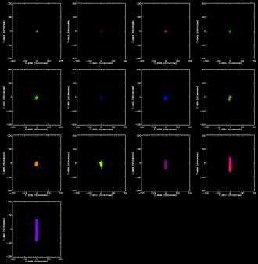 | 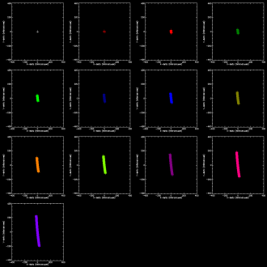 | 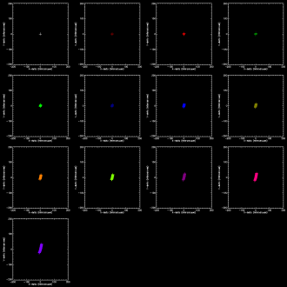 | 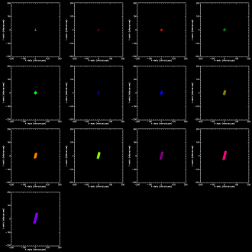
Figure 59. The layout of the 8 plots above is similar as in figure 3: From top to bottom the different bands are shown: I, J, H and K-band. Left is for the image plane ADC, right for the pupil plane ADC. In the above 8 plots the residual chromatic error is shown for one of the points at the edge of the MICADO field. The residual chromatic error is the wavelength dependent distance between center and corner point. What is shown in the 13 sub-plots is the difference between the effect a zenith distance of 0 and given zenith distance from 0 up to 60 degrees at 5 degree interval. Each point indicates the position of a different wavelength within the band, creating a line or curve. Notice the difference in scale! The scale is 400 for the Image plane ADC, which is twice as large than the scale of 200 for the Pupil plane ADC.

 | Image Plane ADC | Pupil Plane ADC
I | 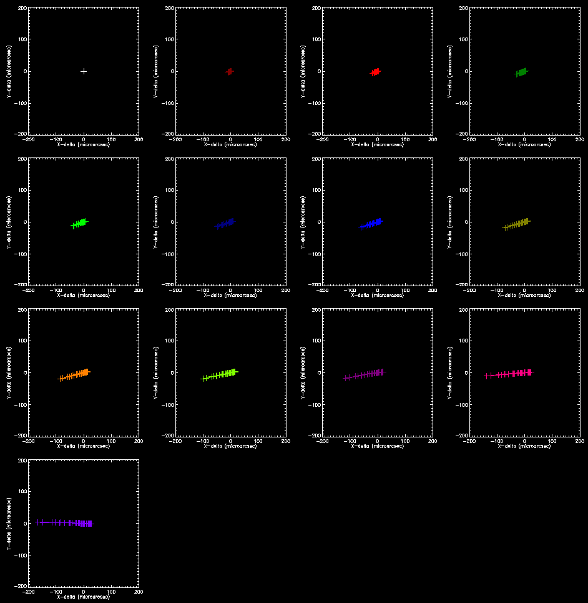  ZD=60°  ZD=55°  ZD=50°  ZD=45°  ZD=40°  ZD=35°  ZD=30°  ZD=25°  ZD=20°  ZD=15°  ZD=10°  ZD=5°  ZD=0°  Scale = 200 micro arcsecond | 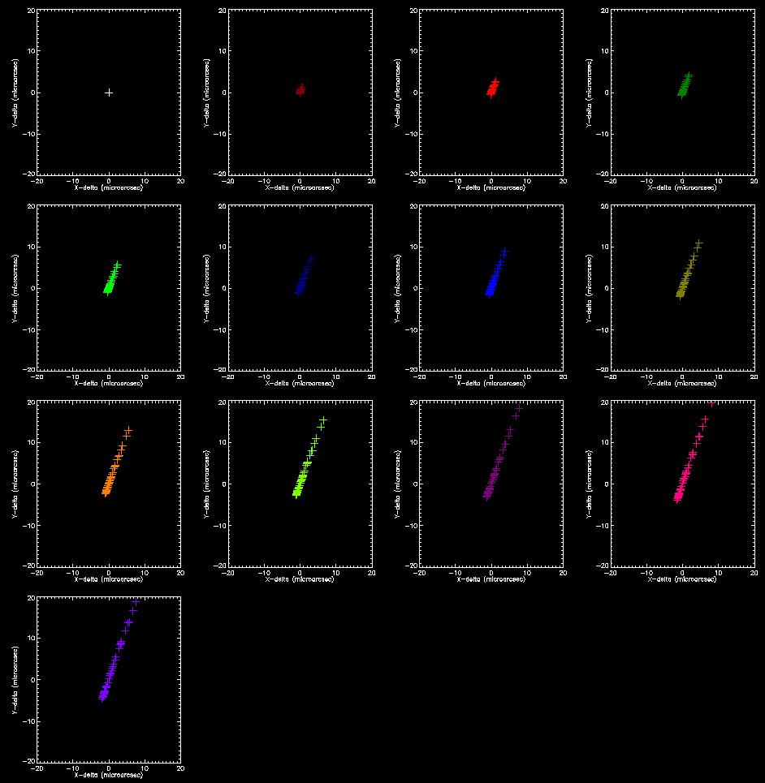  Scale = 20 micro arcsecond
J | 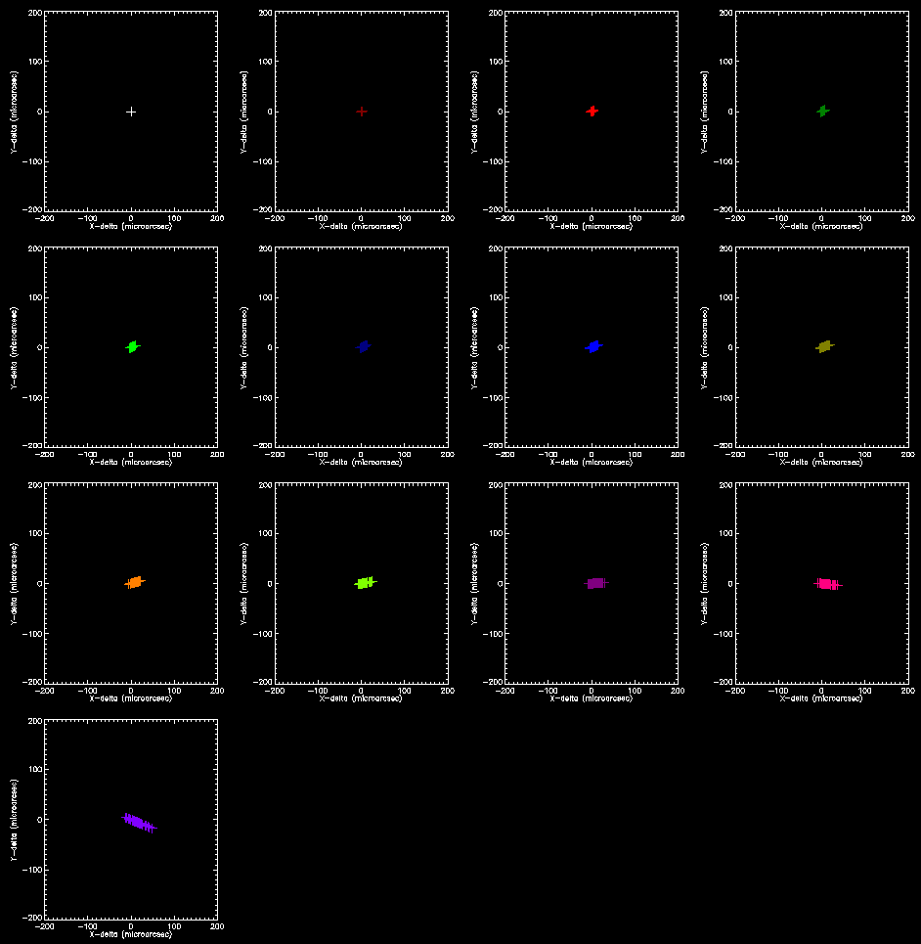  Scale = 200 micro arcsecond  Scale = 20 micro arcsecond | 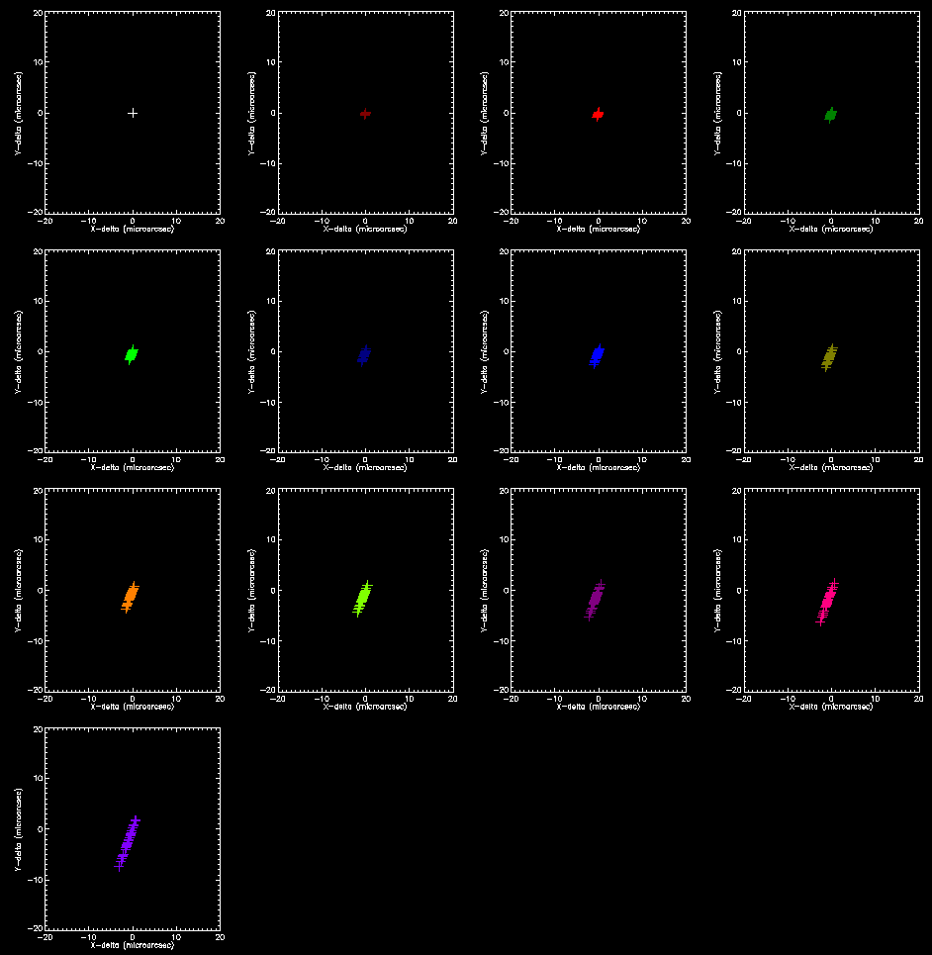
H | 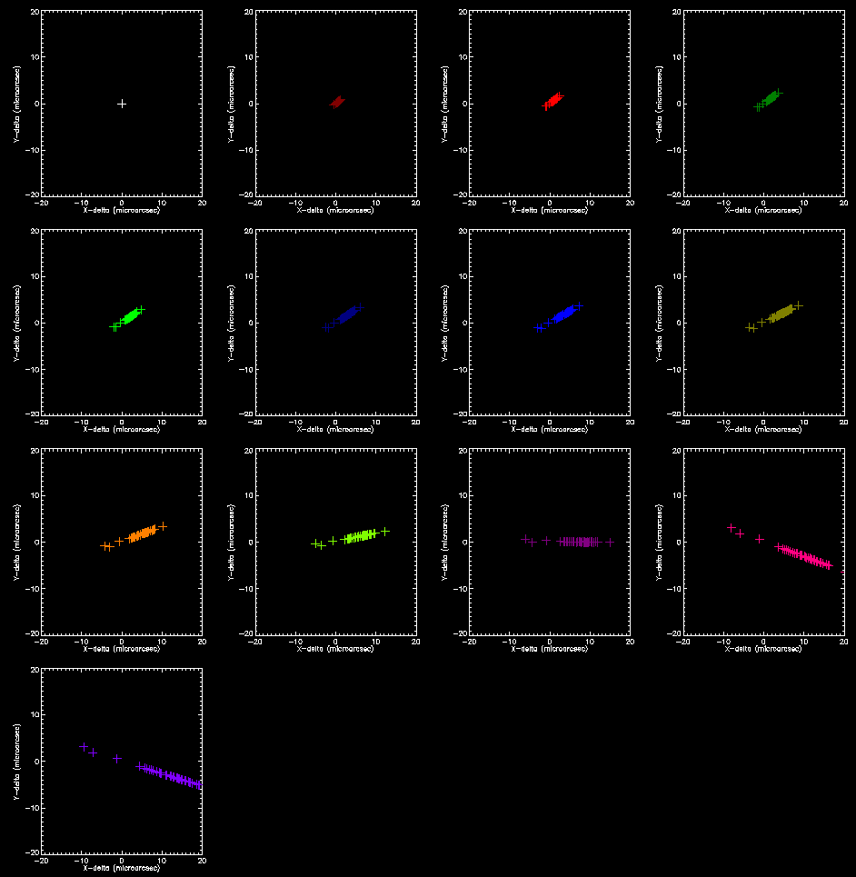  Scale = 20 micro arcsecond  Scale = 20 micro arcsecond  Scale = 20 micro arcsecond  Scale = 20 micro arcsecond | 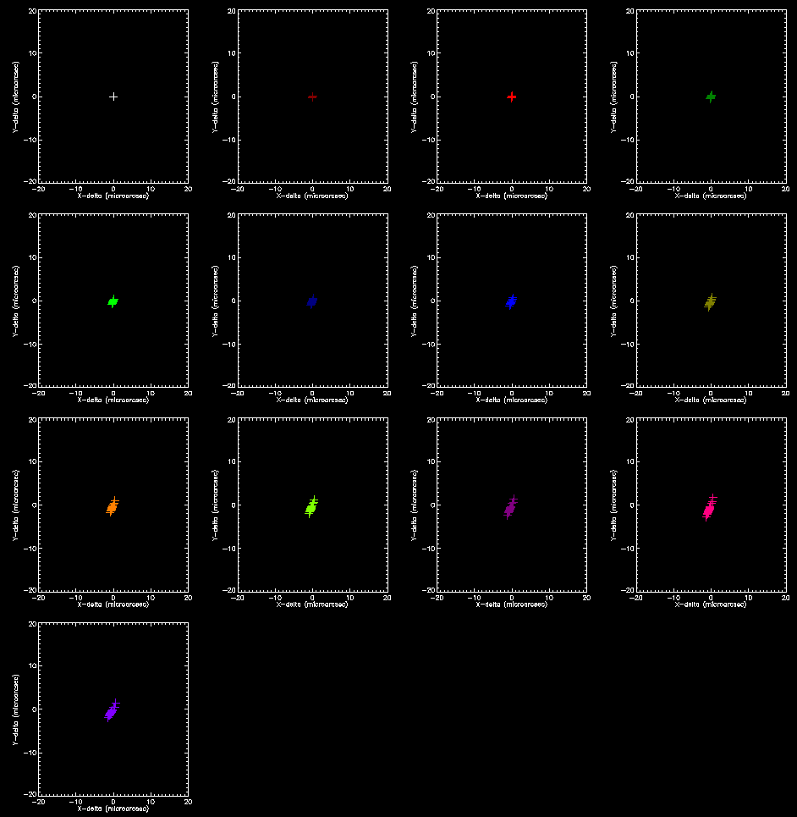
K | 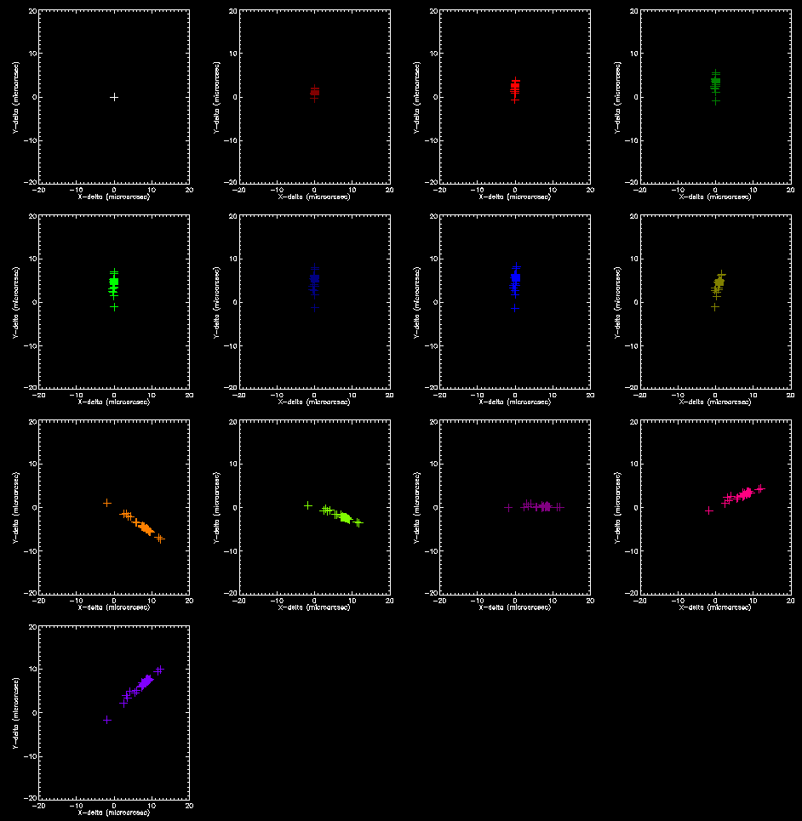 | 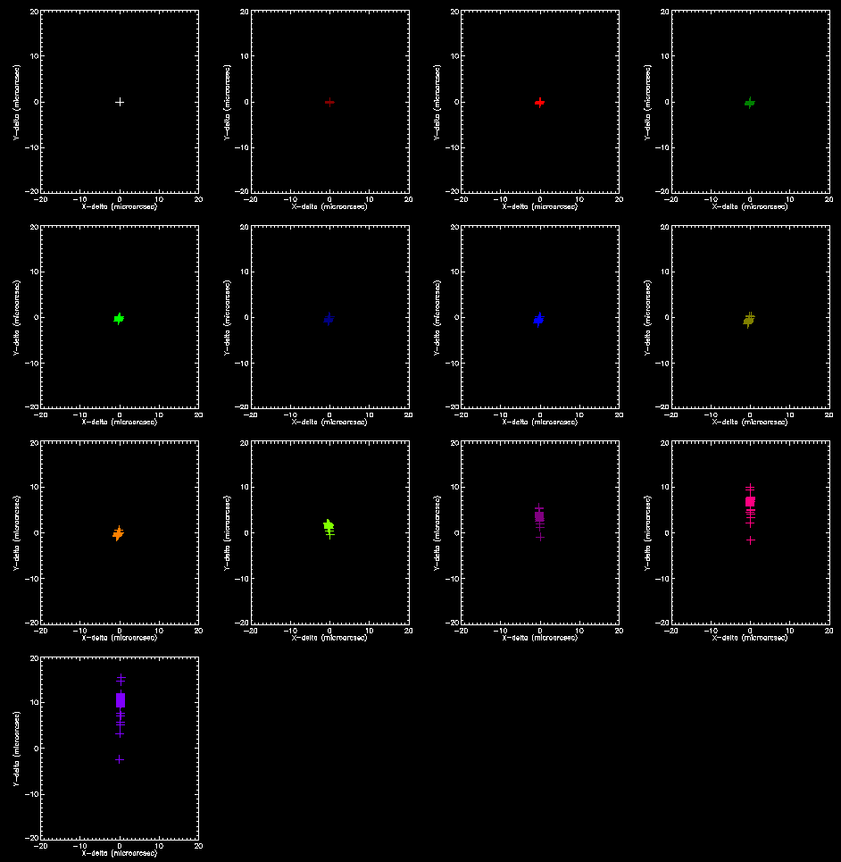
Figure 60. The layout of the 8 plots above is similar as in figure 4: From top to bottom the different bands are shown: I, J, H and K-band. Left is for the image plane ADC, right for the pupil plane ADC. The residual chromatic error is shown for one of the points at the edge of the MICADO field is shown for different stellar types. Each cross indicates a different stellar type. Notice the difference in scale! The scale is 200 micro arcseconds for the Image plane ADC in I-band and J-band, which is ten times larger than the scale of 20 micro arcseconds for the Pupil plane ADC and the scale for the Image plane ADC in H-band and K-band.

Interfaces and requirements from the ADC [Remko/Ramon]
<<include short section on interfaces to other systems of MICADO>>
Guidelines in order to achieve good astrometry: Observe the same field as observed (years) earlier:
- At the same field layout
- at the same field rotation (north on same detector)
- at the same airmass
- at the same side of the meridian

Conclusions [Ramon]
<<Repeat summary table for ADCs>>
<<Indicate that linear ADC is best from point of view of astrometry. Pupil plane ADC is second best. Boundary conditions at this point give a consortium preference to put this in the SCAO pupil plane. Any ADC is required before the MICADO entrance focal plane as the most critical requirement comes from the coronagraph. Linear ADC has advantage that it will remain usable with both the SCAO as well as the MCAO system. A real-time feedback/positioning system would be required for MICADO to maintain the focus and correct for displacements (can also be combined in a folded configuration) and such a motion compensation/vibration damping system might be required anyway, depending on the stability of the platform.
<<Make table of above>>
<<include overview error budget, include SCAO>>
From several simulations, it was demonstrated that several items deemed critical for the astrometric performance are indeed under control and no showstopper have been found. With a SCAO system, Astrometry to a level of xx microarcsec, within yy arcseconds from the guide star seems to be feasible under favorable observing conditions. Extension to the MCAO performance over the full field requires sufficiently accurate simulations on the MCAO, which are not expected to become available for several years to come.
Additional data is required in order to draw stronger conclusions:
- Multiple stars on a grid (e.g. 10 x 10 stars)
- Analyse all 1000 frames of 1 second
- Analyse 20 frames per second (every 50ms) for 1 minute
- Analyse 1 frame per second for 1 hour
With this data it will be possible to simulate if the strategy to use low level distortion polynomials can result in astrometry performance at the required level.

References [All]
- R. Stuik. G. Verdoes Klein, R. Navarro, “Achieving Full Astrometric Accuracy with MICADO and Requirements for the MICADO ADC,” Issue 1.0, 04.03.2013

[1] Andrew C. Phillips, Brian J. Bauman, James E. Larkin, Anna M. Moore, Cynthia N. Niehaus, David Crampton, Luc Simard, The Infrared Imaging Spectrograph (IRIS) for TMT: the atmospheric dispersion corrector’, Proc. SPIE. 7735, Ground-based and Airborne Instrumentation for Astronomy III 77355Q (July 16, 2010) doi: 10.1117/12.856475

<old stuff, delete when no longer needed>
1. MICADO Compliance Matrix, E-TRE-MCD-561-0008
2. Call for Proposal For a Phase A Study of a High Angular Resolution Camera for the E-ELT, Specifications of the Instrument to be studied, E-ESO-SPE-561-0097, Issue 2.0
3. High-precision astrometry with MICADO at the European Extremely Large Telescope, Trippe et al., MNRAS 2010.
4. MICADO Phase A Scientific Analysis Report, E-TRE-MCS-561-0007, Issue 2.0, 19.10.2009
5. http://www.bo.astro.it/maory/Maory/Welcome.html
6. E-SPE-ESO-257-1270 Iss1 07.01.2013 - Top Level Requirements for ELT-CAM
7. Meyer 2011 - Astrometry with the MCAO instrument MAD
8. Neichel 2012 - Science Readiness of the Gemini MCAO System GeMS
9. Rigaut 2012 - GeMS First on-sky results
10. Fritz 2010 - What is limiting near-infrared astrometry in the Galactic Centre
11. Salas 2012 - The Infrared Imaging Spectrograph (IRIS) For TMT - Simulation of the Atmospheric Dispersion Corrector using IDL
12. Atad-Ettedgui 2008 - Atmospheric Dispersion Compensation for ELTs.
13. Goncharov 2007 - Atmospheric dispersion compensation for ELTs
14. Kopon 2010 - An Advanced Atmospheric Dispersion Corrector - The Magellan Visible AO Camera
15. Phillips 2010 - The Infrared Imaging Spectrograph (IRIS) for TMT the Atmospheric Dispersion Corrector
16. Pickles 1998 - A Stellar Spectral Flux Library: 1150-25000 Å

Annex [Tibor]

Transmission of the materials used in the study
In the following the transmission of the materials used in the study are shown. The four materials are ZnSe, ZnS, S-NPH2 and SPINEL (source: rmico.com).
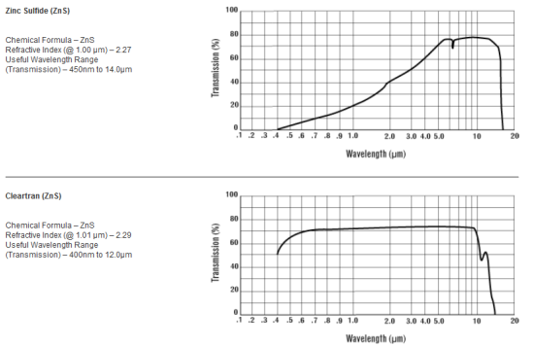 | 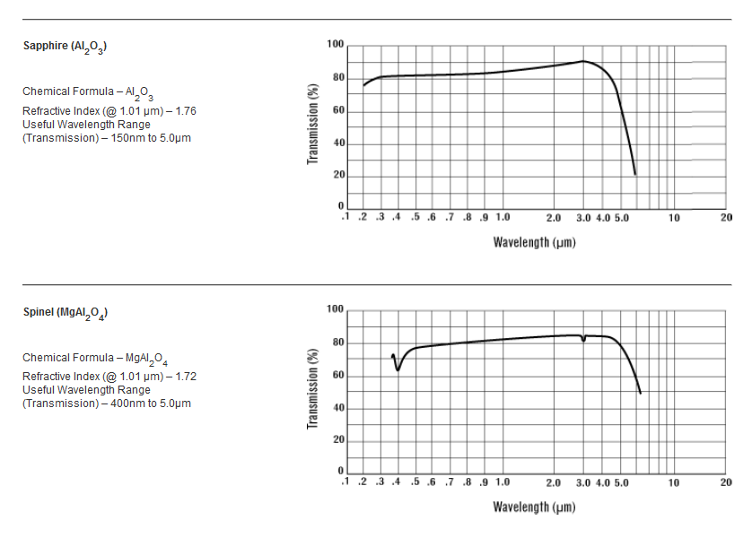
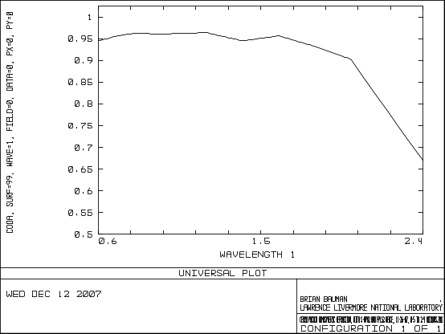
S-NPH2

Material properties of materials used in the study
 | ZnSe | ZnS | S-NPH2 | Spinel
Density (g/cm3) | 5.27 | 4.09 | 3.58 | 3.58
Youngs Modulus GPa | 67.2 | 74.5 | 99.1 | 276
Poisson’s Ratio σ | 0.29 | 0.28 | 0.249 | 0.26
Thermal Expansion 10⁻⁶/K | 7.57 (293K) | 6.3 (273K) | 6.7(240-340K) | 6.97(303-473K)
Thermal Conductivity W/(m.K) | 18 | 27.2 | 0.969 | 25

Optical aberrations (RMS vs field, RMS vs wave)
RMS spot radius vs. field and RMS spot radius vs. wavelength are shown for 65 degree zenith angle configuration for each ADC design.
Phase A ADC | 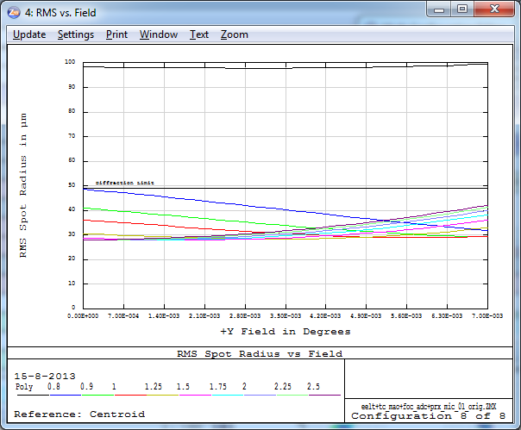 | 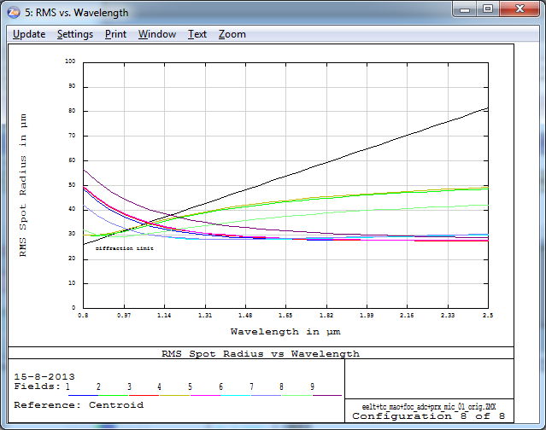
Counter rotating ADC | 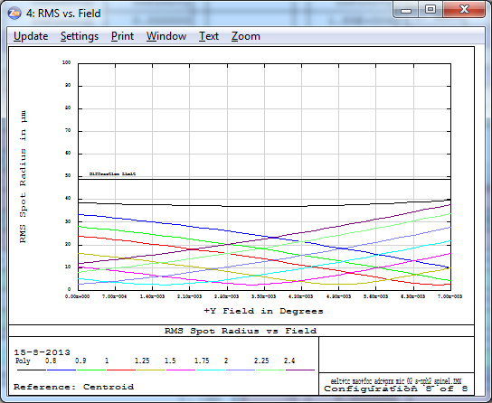 | 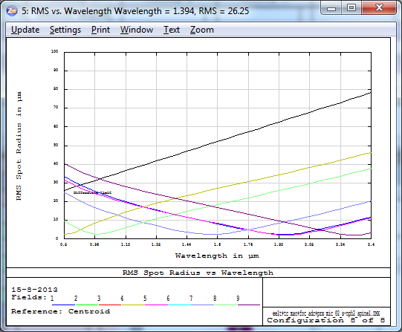
Counter rot. ADC (zero-dev.) | 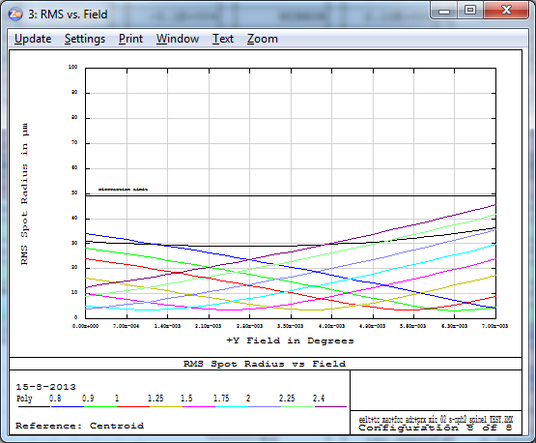 | 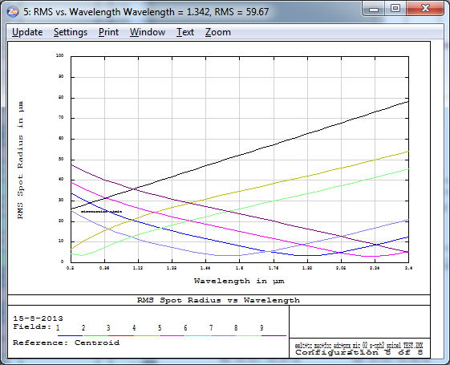
Linear ADC | 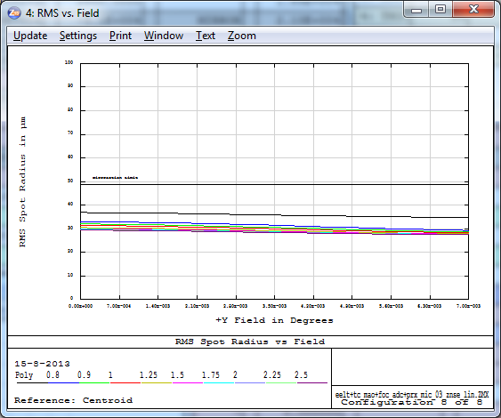 | 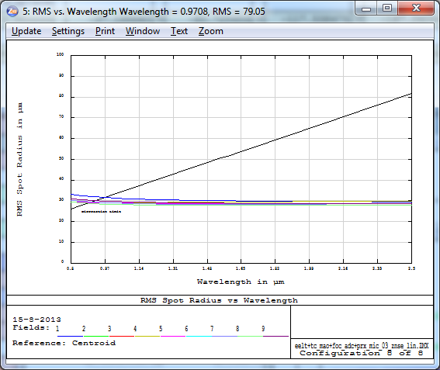
Linear ADC (zero-dev.) | 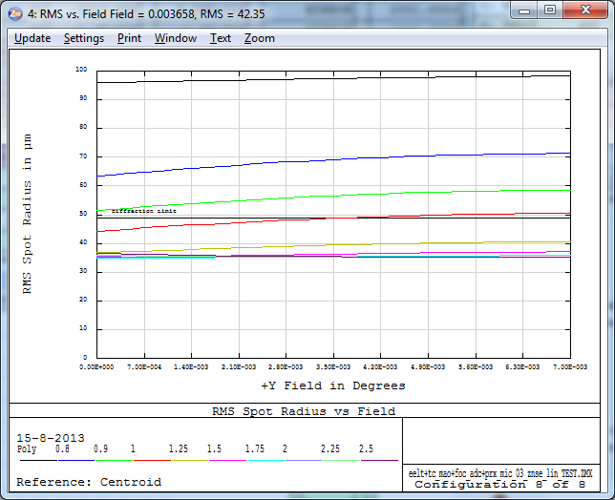 | 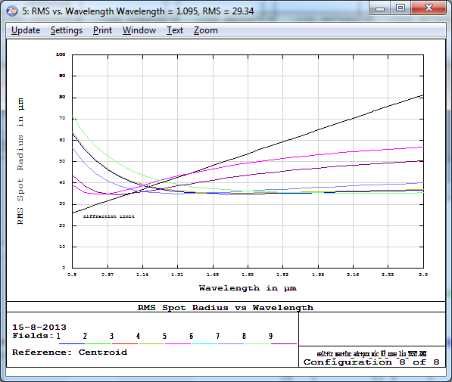
Linear ADC with fold mirror | 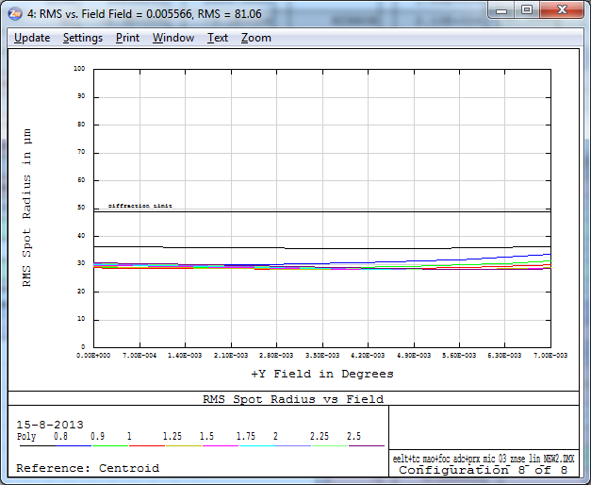 | 