OmegaCAM Illumination Variation and Correction

Reports
- OmegaCAM Commissioning - DFS - Illumination Characterisation and CorrectionIllumination Report v2.1 VST-TRE-OCM-23100-3608 ocam_illum.pdf

Supplements
- Accompanying movie of twilightflat residuals vs rotator angle:
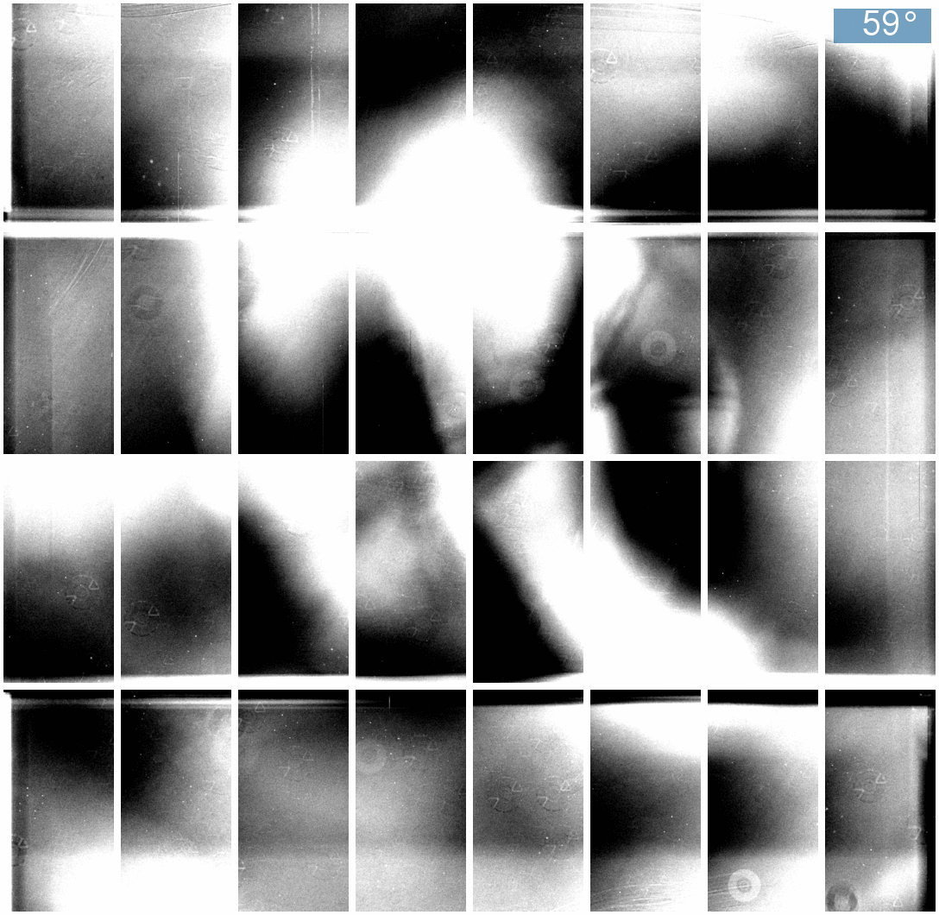

Links
Internal page on Illumination variations and correction for OmegaCAM

